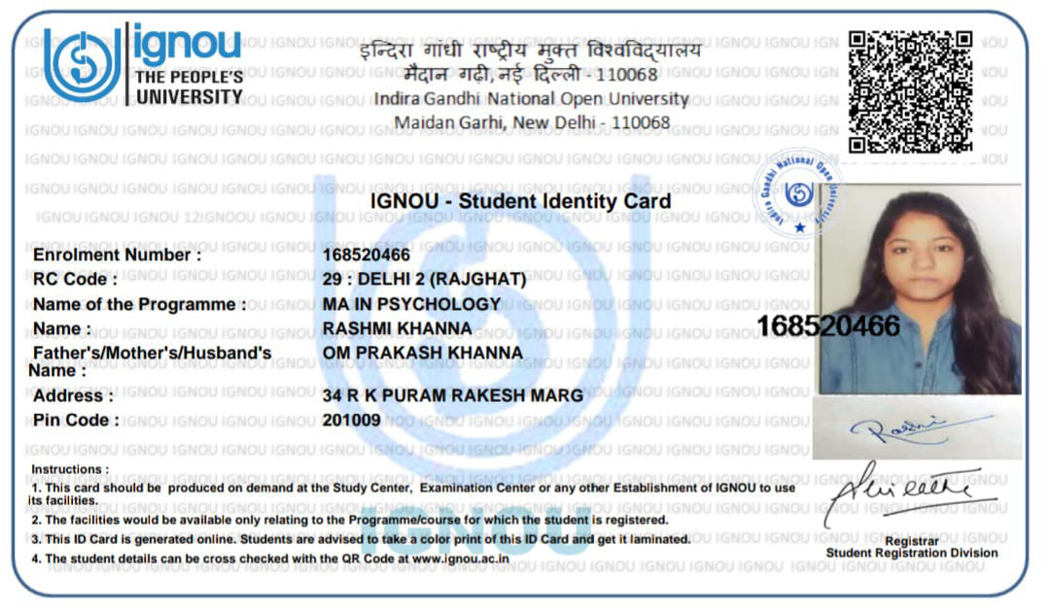

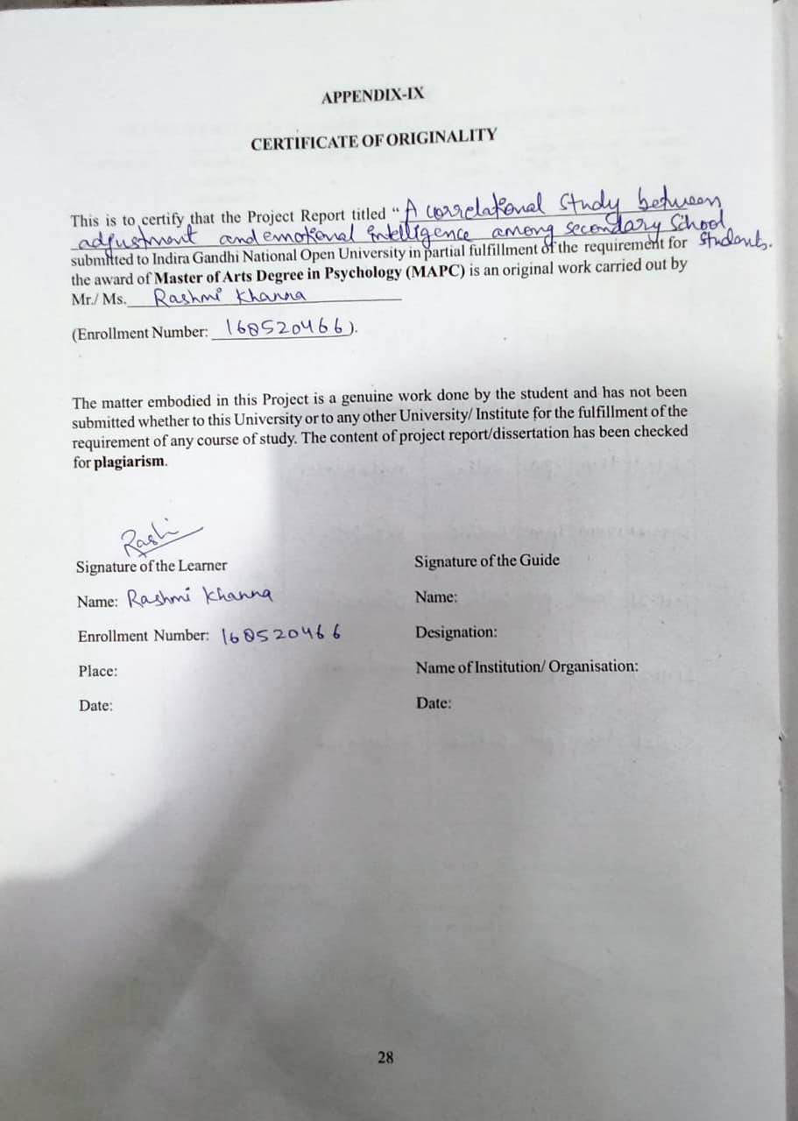

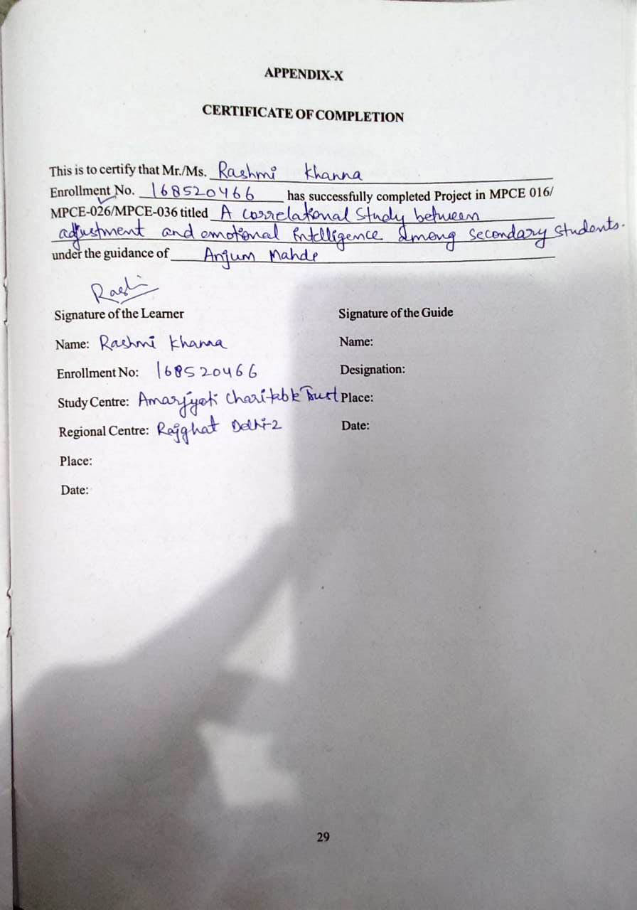

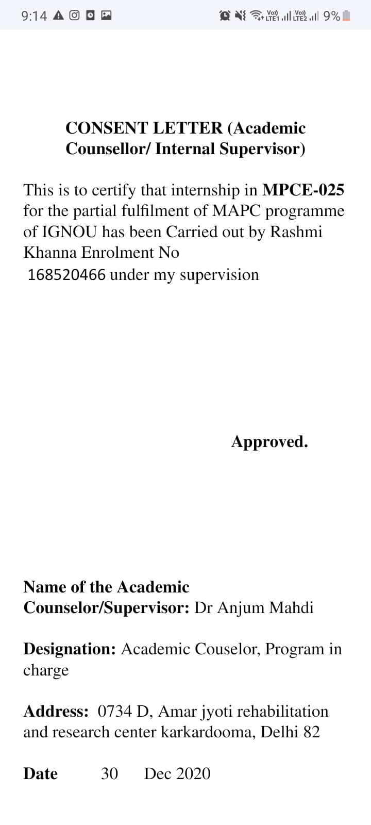

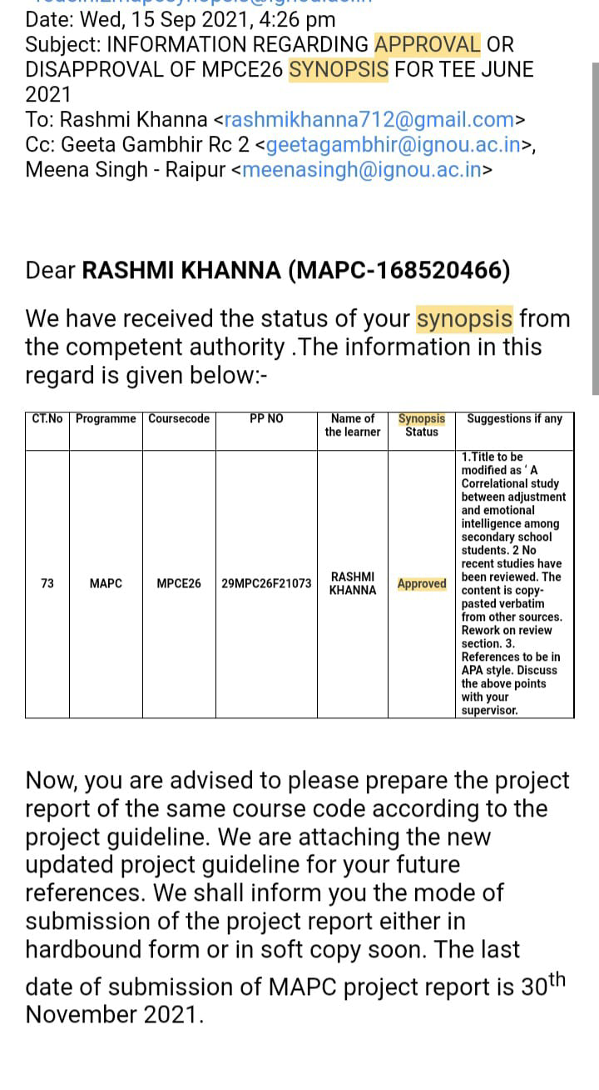

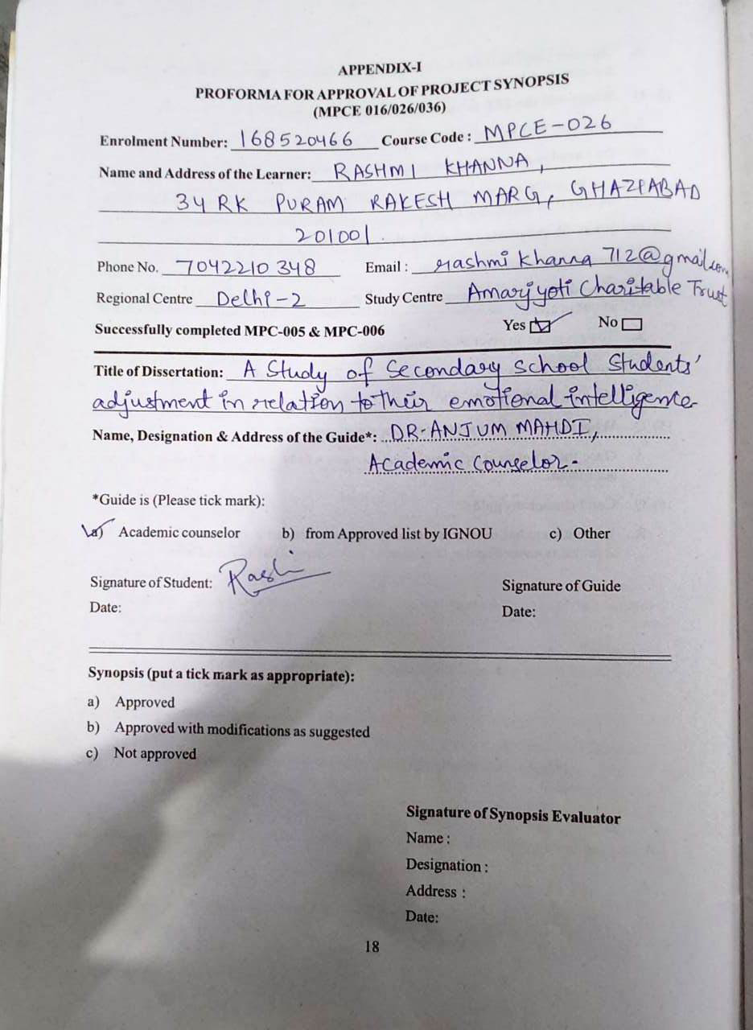

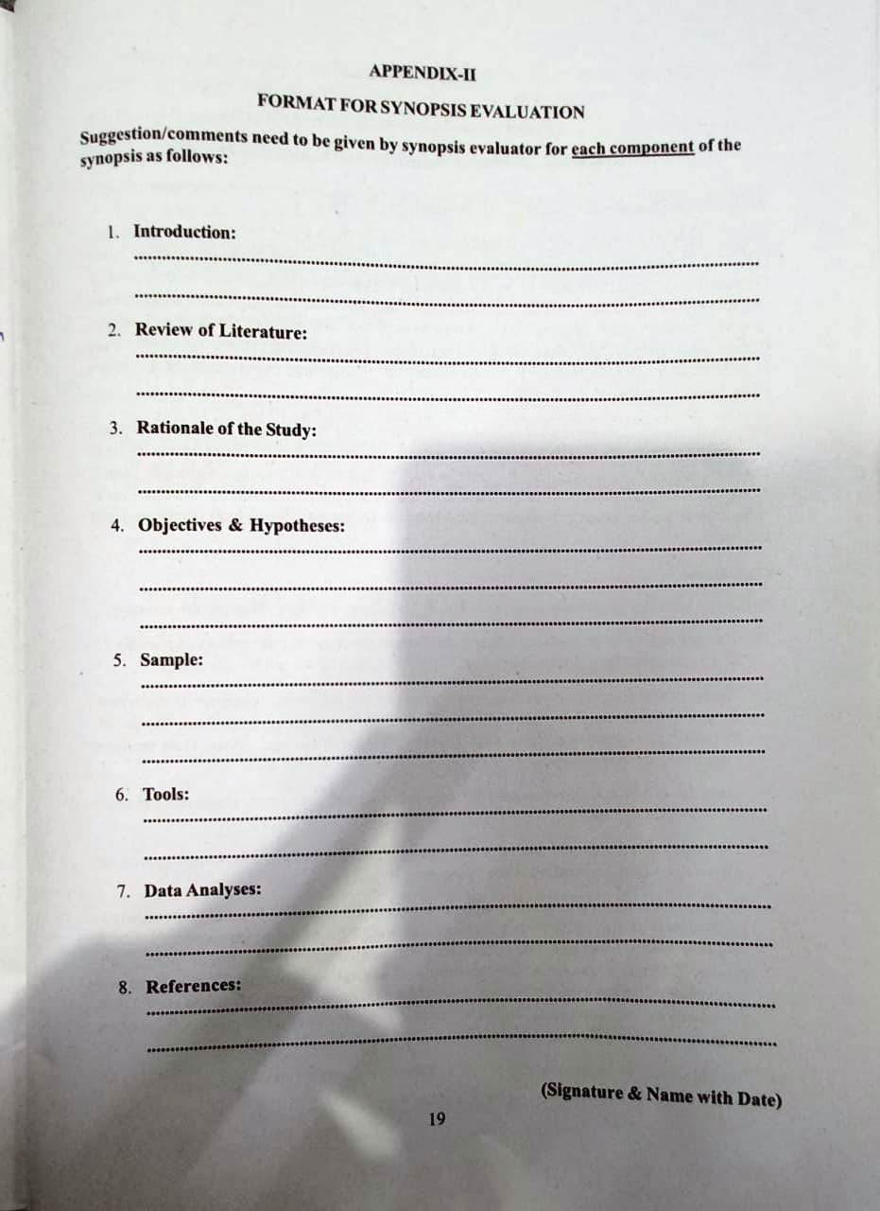

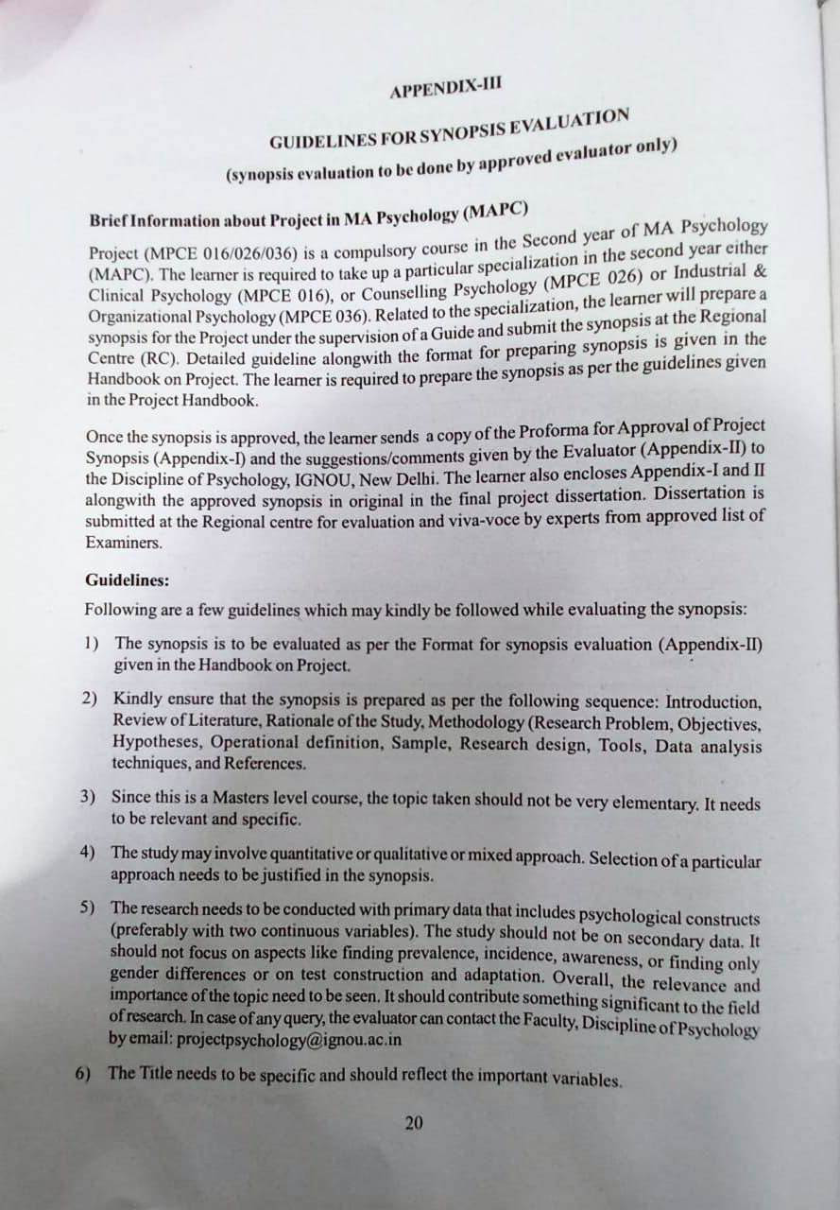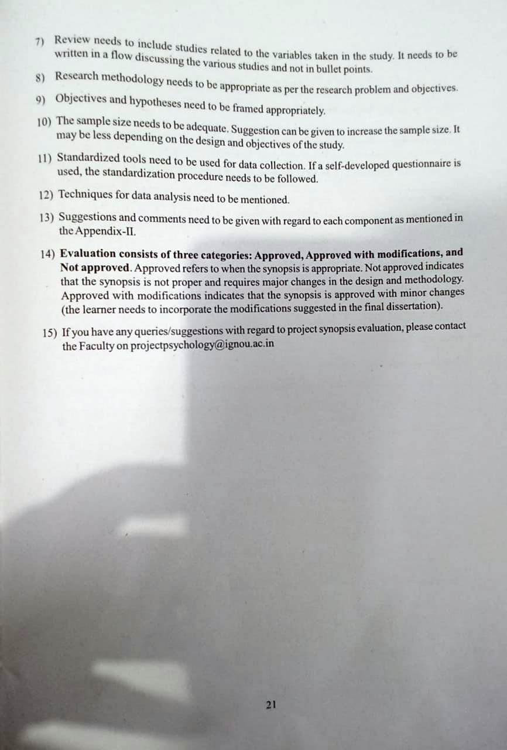

**A STUDY OF SECONDARY SCHOOL STUDENTS’ ADJUSTMENT IN RELATION TO THEIR EMOTIONAL INTELLIGENCE**

**A Research Proposal**

**in**

**Counselling Psychology**

**By**

**RASHMI KHANNA**

**168520466**

**Under the supervision of**

**DR. ANJUM MAHDI**

**INTRODUCTION**

The concept of emotional intelligence can be used effectively in solving these problems and helps the individual to adjust in the society. In the recent years, the great interest in emotional intelligence on the part of corporations, universities and schools have seen. The idea of emotional intelligence has inspired research and curriculum development throughout these facilities to improve educational curriculum and incorporate these principles into everybody learning for students. Building one’s emotional intelligence has a lifelong impact. Many parents and educators, alarmed by increasing levels of conflict in young school children from low self-esteem to early drug and alcohol use to depression, are rushing to teach students the skills necessary for emotional intelligence. And in corporations, the inclusion of emotional intelligence in training programs has helped employees co-operate better and motivate more, thereby increasing productivity and profits, researches have concluded that people who manage their own feelings well and deal effectively with others are more likely to live content lives. Plus, happy people are more apt to retain information and do so more effectively than unsatisfied people.

The concept of adjustment is as old as human race on earth. Systematic emergence of this concept starts from Darwin. In those days the concept was purely biological and he used the term adaptation. The adaptability to environmental hazards goes on increasing as we proceed on the psychogenetic scale from the lower extreme to the higher extreme of life. Insects and germs, in comparison to human beings, cannot withstand the hazards of changing conditions in the environment and as the season changes, they die. Hundreds of species of insects and germs perish as soon as the winter begins.

Psychologists have interpreted adjustment from two important points of views. One is adjustment as an achievement and another, adjustment as a process. The first point of view emphasizes the quality or efficiency of adjustment and the second lays emphasis on the process by which an individual adjusts in his external environment.

**REVIEW OF LITERATURE**

**According to Surekha (2008)** adjustment refers to a harmonious relationship between the person and the environment that affords him comfortable life devoid of strain, stress, conflict and frustration. The present researcher made an attempt to study the existing adjustment problems of the students, which involve emotional and educational dimensions. Further an attempt has been made to study the relationship between the adjustment of the learners and their academic achievement. A normative survey method was used for the present research. A sample of 115 students of Warangal City in Andhra Pradesh was selected by simple random sampling technique. the researcher has formulated the following objectives for the present study: to study the adjustment problems and academic achievement of private and government school students; to study the adjustment problems and academic achievement of boys and girls studying in private and government schools; to establish the relationship, if any, between adjustment problems and students’ academic achievement; to study the mean differences, if any, between the level of adjustment (good, average and poor) of the students with their academic achievement. The study revealed that the boys and girls from private schools are well adjusted and academically performed better than the boys and girls from government schools. The co-efficient of correlation between the students’ adjustment and academic achievement is found to be -0.29, which is significant at 0.01 level. If indicates that low scores in adjustment tend to accompany with high scores in academic achievement.

**Suresh K. J. &Joshith V. P. (2008)** finds a significant negative relationship between emotional intelligence with adjustment for the total sample and sub-samples, and concludes that individuals having high emotional intelligence may have low stress and this will directly contribute to the positive development of the individual and the society. The main objectives of the study were: (1) to test whether there is a significant difference in the mean scores of stress between (a) male and female student teachers (b) student teachers of aided, unaided and government training colleges (c) science and arts student teachers (2) to test whether there is a significant difference in the mean scores of emotional intelligence between (a) male and female student teachers (b) student teachers of aided, unaided and government training colleges (c) science and arts student teachers (3) to find out the extent of relationship between emotional intelligence with adjustment of the student teachers (4) to find out whether the relationship between emotional intelligence with adjustment in different for the sub-samples (a) male and female student teachers (b) student teachers of aided, unaided and government training colleges (c) science and art student teachers. The findings of the study suggest that emotional intelligence with adjustment are negatively related to each other, i.e. a person having high emotional intelligence may have low stress and vice versa. This world is full of fears, doubts and excess parental pressure and cutthroat competition in academic levels. The students are compelled to excel in performance irrespective of their potential. The overemphasis on academic achievements given by parents and teachers makes the students eliminate the emotional components, which will result in failure in their life ultimately, so in these circumstances individuals should be trained to behave with emotional intelligence to make their life free from all types of stress.

**RATIONALE OF THE STUDY**

The adjustment of secondary school students depend on emotional intelligence and several associated factors. Several studies had provided substantial evidence flavouring adjustment, for quality education. Complexity and multi-dimensional nature of adjustment warrants a comprehensive study of factors related with it.

A student’s emotional intelligence measured through his E.Q. may be great predicator of success than IQ. One’s emotional intelligence is unitary ability helpful in knowing, feeling and judging emotions in close cooperation with

one’s thinking process to behave in a proper way, for the ultimate realization of happiness and welfare of self in tone with other.

An overview of` the survey of Literature reveals that so for no serious effort has been undertaken to study the emotional intelligence and adjustment of secondary school students. Therefore, the investigator feels it important to conduct a research on emotional intelligence and adjustment of secondary school students of Ghaziabad.

**OBJECTIVES AND AIM OF THE STUDY**

* The following objectives are formulated for the present study: -
* To study the relationship between emotional intelligence and adjustment among senior secondary students.
* To study the emotional intelligence and adjustment of secondary school students.
* To study the difference between the mean adjustment scores of students having high and low emotional intelligence.
* To study the difference between the mean adjustment scores of male and female students having high emotional intelligence and low emotional intelligence.

**HYPOTHESIS OF THE STUDY**

The following hypotheses are formulated for the present study: -

* H1. There will be no significant relationship between Emotional Intelligence and Adjustment among Senior Secondary Students.
* H2. There will be no significant difference between the mean Adjustment scores of students having high and low Emotional Intelligence.
* H3. There will be no significant difference between the mean Adjustment scores of male and female students having high Emotional Intelligence.
* H4. There will be no significant difference between the mean Adjustment scores of male and female students having low Emotional Intelligence..

**DESIGN OF THE STUDY**

**Research Method**

Evaluative research technique of Descriptive Research will be employed to carry out this piece of research work.

**Sample**

A sample is a small portion of a population selected for observation and analysis. By observing the characteristics of the sample, one can make certain inferences about the characteristic of the population from which it is drawn. For the present study, 200 students (100 male and 100 female) 5 Co-Ed. Private Senior Secondary Schools in Ghaziabad will constitute the sample. Simple random sampling technique will be adopted to draw the sample from the universe by which every unit of the universe will provided equal chance of inclusion in the sample.

**Inclusion or Exclusion**

• Only Senior Secondary Studentsin Ghaziabad will be included in the study.

• Only 200 students (100 male and 100 female) 5 Co-Ed. Private Senior Secondary Schools in Ghaziabadwill be included in the study.

• The age range of the participants will be varied from 14-17.

• Disabled students will be excluded from the study.

**Test & Tools**

***1. Emotional Intelligence Scale (EIS)-(2007)***

Emotional Intelligence Scale prepared by Anokool Hyde, SanjyotPethe and UpinderDhar will be used to measure Emotional Intelligence of adolescent students.

***Reliability***

The reliability of the scale was determined by calculating reliability coefficient on a sample of 200 subjects. The split-half reliability coefficient was found to be 0.88,

***Validity***

In order to find out the validity from the coefficient of reliability (Garrett, 1981), the reliability index was calculated, which indicated high validity on account of being 0.93.

***2. Bell Adjustment Inventory***

Bell adjustment inventory (student form) is one of the most widely used personality inventories. The inventory was developed by H. M. Bell in the year 1934. In the process of adaptation, the inventory was once again subjected to all the technical procedures for test standardization which renders it especially suitable for use in the Hindi speaking areas. Since the standardization samples comprised undergraduate students of different rural and urban colleges, this inventory can be used in the final classes of the high schools and also in colleges, individual as well as group situations.

**Reliabilities:** Both test-retest and odd-even reliabilities of different areas as also of the total test are summarized as:

**Validity:** The items of each sub-scale were selected on the basis of the strength of their association with the total test scores in the sub-test. For this purpose, the method of extreme groups’ comparison was used consisting of the 27% upper and 27% lower scoring groups following Kelley’s (1939) recommendation.

**Procedure**

To begin with the research, the researcher will contact the 200 students (100 male and 100 female) 5 Co-Ed. Private Senior Secondary Schools in Ghaziabad. The nature of the study will be explained to them, consent of the students regarding data collection will be taken and they will be assured of confidentiality. To study the significant difference between the variable of the study, t-test will be used. In addition, to estimate the strength of an association between variables, there will be need for using the correlation coefficient. The measures of correlation coefficient tend to be close to zero when there is no association and close to the maximum (or minimum) value when there is perfect association. SPSS software will be used for data analyzing in this study. The test will be conducted, score obtained will be calculated for each subscale, raw score will be converted into percentile score and then interpretations, conclusions and suggestions will be made on that basis.

**Statistical Analysis**

In this proposed study, various statistical tool and techniques will be used according to the requirement of the study. Percentage, Mean, S.D., t-test and Pearson Coefficient of correlation will be calculated

**REFERENCES**

* Aggarwal, Y.P. (2007). The Science of Education Research; Kurukshetra: Nirmal Book Agency.
* Aggarwal, Y. P. (2007). Statistics in Education; Delhi: Sterling Publications.
* Ahuja, G. C. (1976). Handbook for group test of intelligence: 13 to 17+ years, Agra, National Psychological Corp.
* Baron, J. (1992). Personality and intelligence. In R. J. Sternberg (Ed.). Handbook of human intelligence. New York: Cambridge University Press (pp. 308-351).
* Bowers, K. S., & Kelly, P. (1979). Stress, disease, psychotherapy, and hypnosis. Journal of Abnormal Psychology, 88, 506-526.
* Mangal, S.K. (2004). Advanced Education Psychology (2nd edition); New Delhi: Prentice- Hall of India Ltd.
* Manisha (2009). Emotional Intelligence as a measure for success in life, Edutracks. Vol. 8. No. 11, Nilkamal Publications, Hyderabad, p.18-19.
* Mishra Mukti, RaoVaishali and BhatpahariGautami (2008). Emotional Intelligence of college girls, Indian Journal of Psychometry and Education, 39(2): p.150-152, Patna.
* Mohan, Radha (2009). An exploration of the utility of a self-report emotional intelligence measure: pre-service teacher education, Edutracks. Vol. 8. No. 10, Nilkamal Publications, Hyderabad, p.30-35.
* Panda, Sumanta Kumar (2009). Emotional Intelligence and personality traits of pupil- teachers, Journal of Community Guidance and Research (2009). Vol. 26 No. 2, ISSN-0970-1346, p.122-136..
* Singh, Smita and Koteswari, VermireddyBala (2006). Emotional Intelligence and coping resources of stress among project managers, Edutracks. Nilkamal Publications, Hyderabad, p.33-36.
* Subramanyam, K. and RaoSreenivasa K. (2008). Academic achievement and emotional intelligence of secondary school children, Journal of Community Guidance and Research. Vol. 25 No. 1, ISSN-0970-1346, p.224-228.

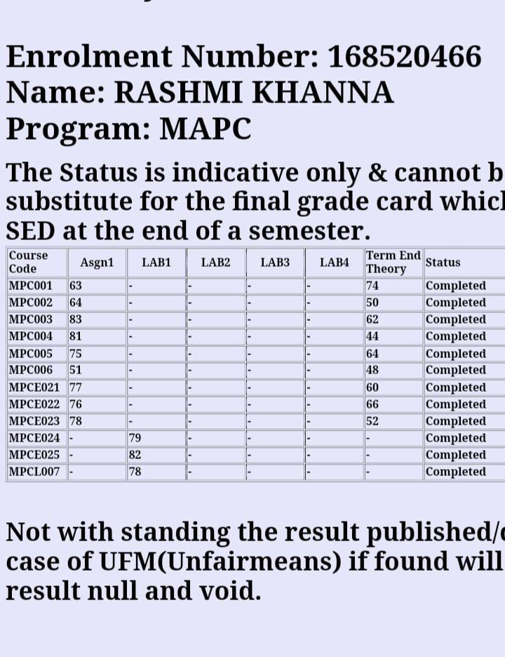

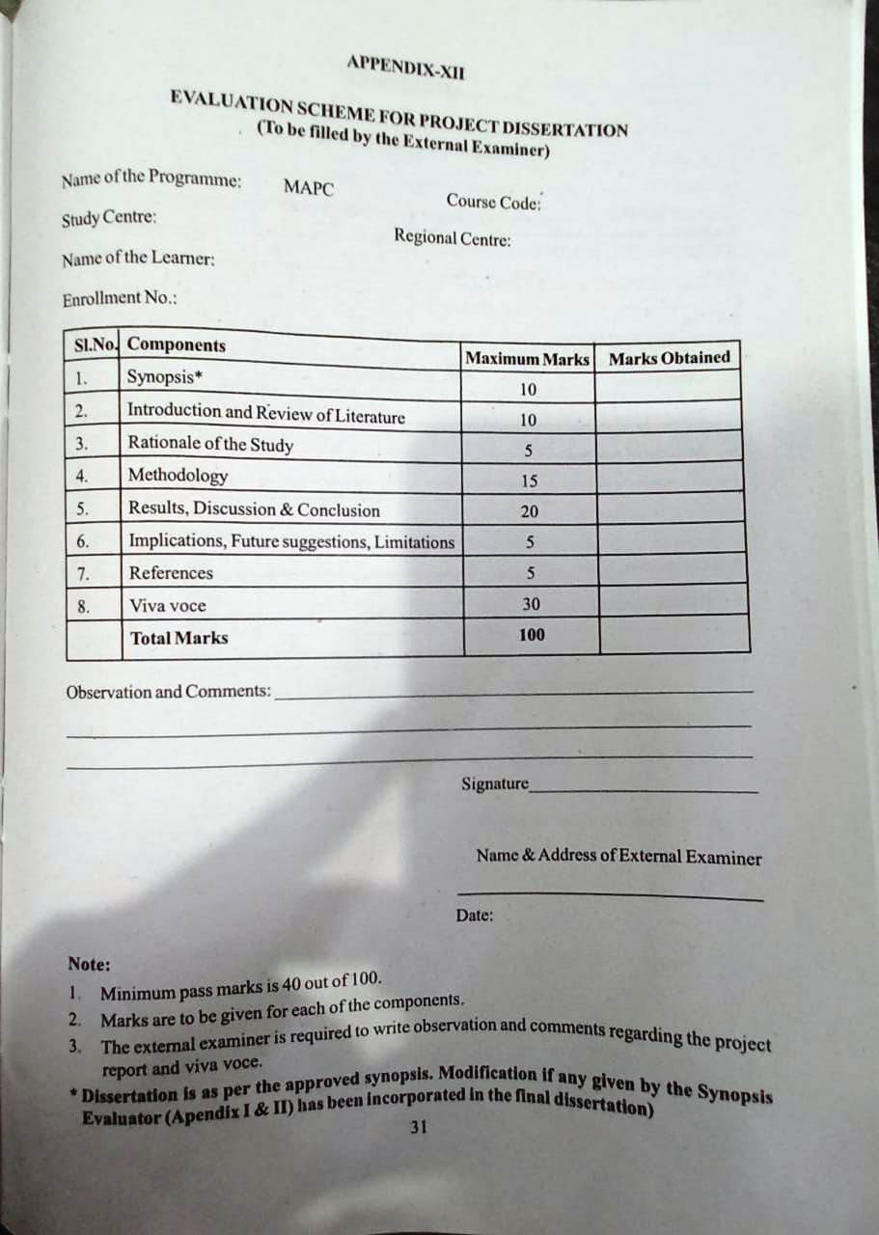

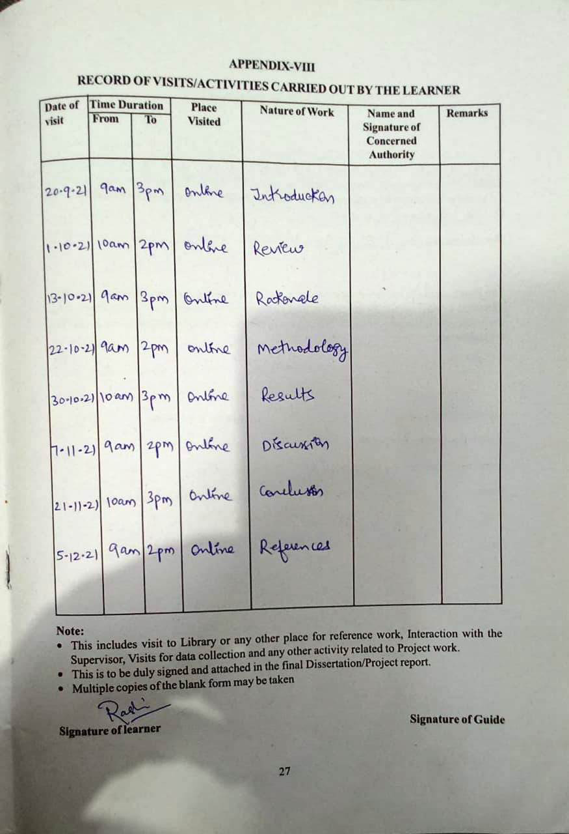

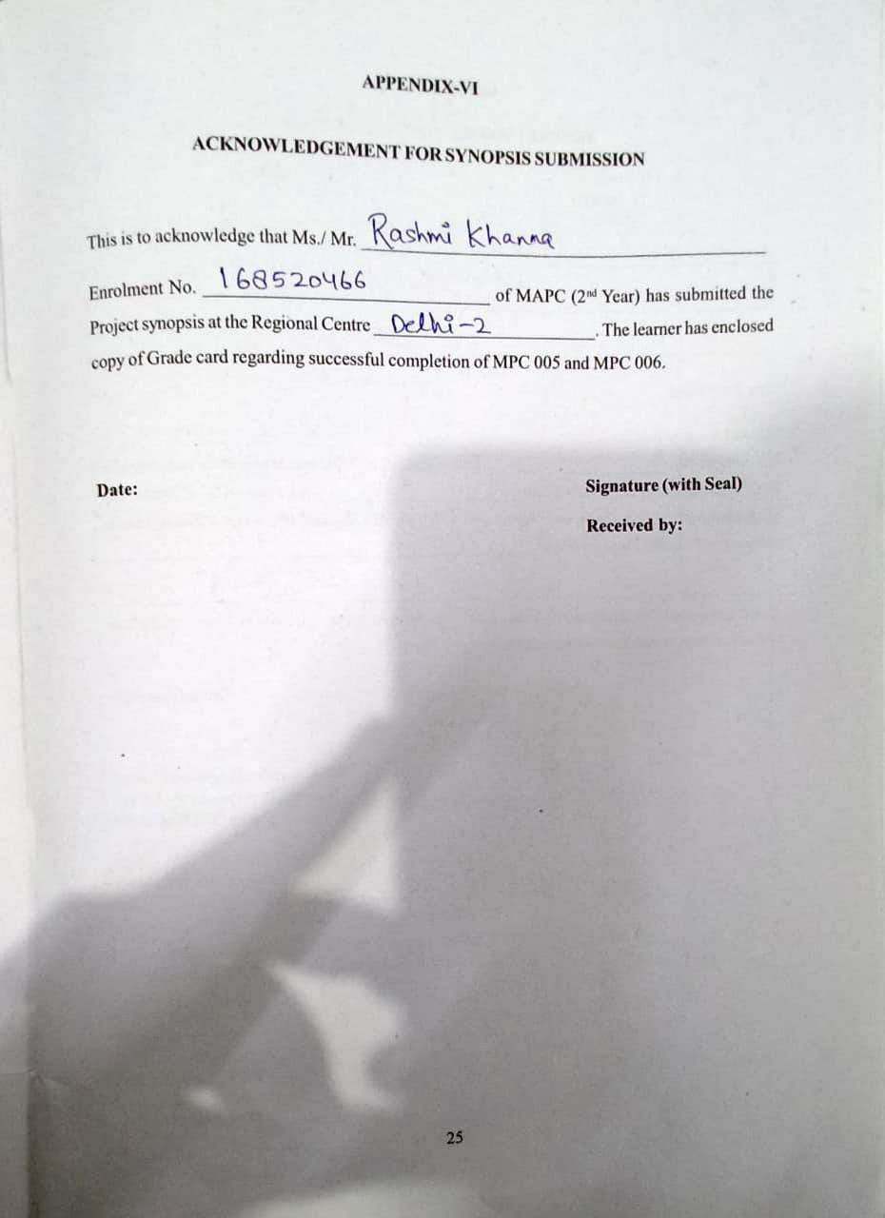

**TABLE OF CONTENT**

| **SR. NO** | **CHAPTER NAME** |
| --- | --- |
| **1.** | **ABSTRACT**  **INTRODUCTION** |
| **2.**  **3.**  **4.** | **REVIEW OF RELATED LITERATURE**  **RATIONALE OF THE STUDY**  **METHODOLOGY** |
| **5.**  **6.**  **7.**  **8.** | **RESULT, INTERPRETATION AND DISCUSSION**  **CONCLUSIONS**  **DELIMITATIONS & SUGGESTIONS FOR FURTHER WORK**  **REFERENCES** |

|  |
| --- |
|  |
|  |

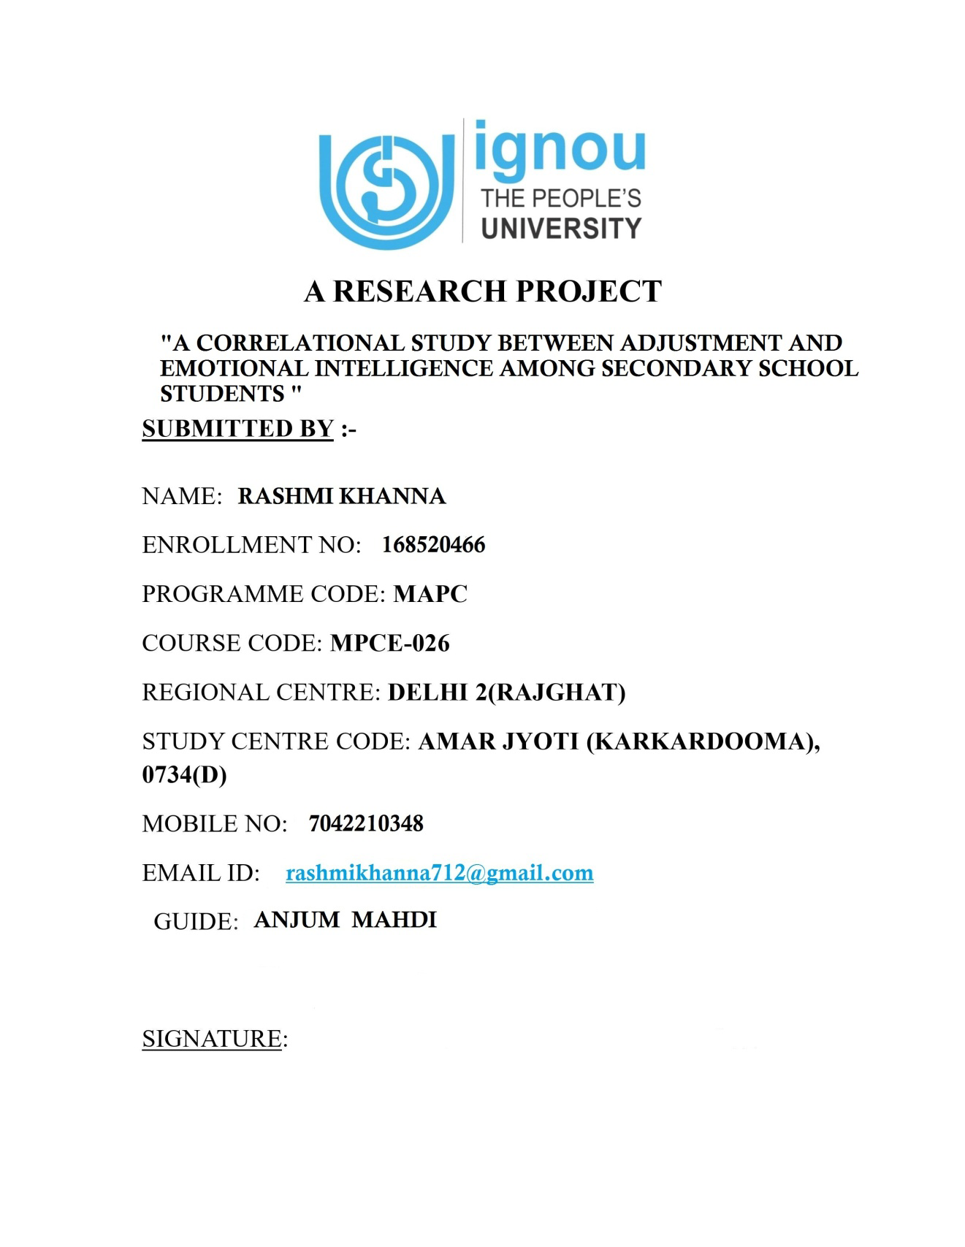

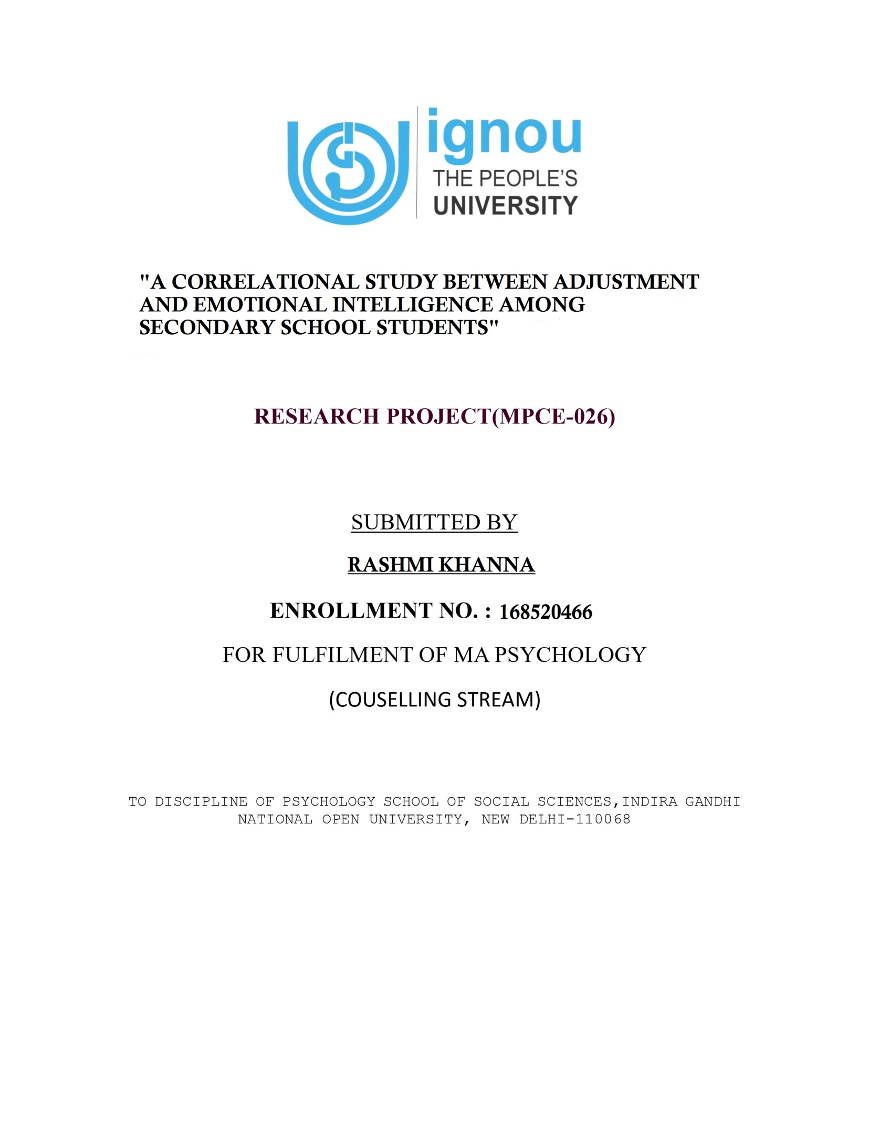

**PROJECT REPORT**

**A CORRELATIONAL STUDY BETWEEN ADJUSTMENT AND EMOTIONAL INTELLIGENCE AMONG SECONDARY SCHOOL STUDENTS**

BY

RASHMI KHANNA

168520466

**CERTIFICATE OF ORIGINALITY**

This is to certify that the Project Report titled A CORRELATIONAL STUDY BETWEEN ADJUSTMENT AND EMOTIONAL INTELLIGENCE AMONG SECONDARY SCHOOL STUDENTS submitted to Indira Gandhi National Open University in partial fulfillment of the requirement for the award of MASTER OF ARTS DEGREE IN PSYCHOLOGY (MAPC) is an original work carried out by RASHMI KHANNA (Enrolment Number: 168520466).

The matter embodied in this Project is a genuine work done by the student and has not been submitted whether to this University or to any other University/ Institute for the fulfillment of the requirement of any course of study.

**Signature of the Learner Signature of the Supervisor**

**Name: RASHMI KHANNA Name: …………………………**

**Enrolment Number: 168520466 Designation: …………………….**

**Date: Date:**

**CERTIFICATE**

This is to certify that **Miss.** **RASHMI KHANNA** student of MASTER OF ARTS DEGREE IN PSYCHOLOGY (MAPC) from Indira Gandhi National Open University, New Delhi was working under my supervision and guidance for her Dissertation for the course MAPC-…….. Her Dissertation entitled A CORRELATIONAL STUDY BETWEEN ADJUSTMENT AND EMOTIONAL INTELLIGENCE AMONG SECONDARY SCHOOL STUDENTS which she is submitting, is her genuine and original work.

**Signature:**

**Name: ANJUM MAHDI**

**Address of the supervisor:**

**………………………………………………………………………………………………………….**

**ACKNOWLEDGEMENT**

I feel indebted to my guide ANJUM MAHDI for the completion of the dissertation entitled A CORRELATIONAL STUDY BETWEEN ADJUSTMENT AND EMOTIONAL INTELLIGENCE AMONG SECONDARY SCHOOL STUDENTS. The present work could be completed only because of the able guidance and affectionate attitude of my guide …ANJUM MAHDI SIR

I am thankful to all respondents and all those who assisted me by supplying the requisite information towards the completion of the questionnaire there by enable me to collect the relevant data.

**Name: RASHMI KHANNA**

**Enrolment Number: 168520466**

**ABSTRACT**

Emotional intelligence addresses the emotional, personal, social and survival dimensions of intelligence which are often more important for daily functioning that the more cognitive or mental aspect of intelligence. Emotional intelligence is in many ways a predictor of emotional and personal success in the future. The concept of adjustment is as old as human race on earth. Systematic emergence of this concept starts from Darwin. In those days the concept was purely biological and he used the term adaptation. The adaptability to environmental hazards goes on increasing as we proceed on the psychogenetic scale from the lower extreme to the higher extreme of life. Insects and germs, in comparison to human beings, cannot withstand the hazards of changing conditions in the environment and as the season changes, they die. Hundreds of species of insects and germs perish as soon as the winter begins.

The objective of the study is to study the relationship between emotional intelligence and adjustment among senior secondary students. The hypotheses formulated for the present study that there is no significant relationship between Emotional Intelligence and Adjustment among Senior Secondary Students.

Further, evaluative research technique of Descriptive Research was employed to carry out this piece of research work. 200 students (100 male and 100 female) from 5 Co-Ed. Government School was taken for the study. Further, Emotional Intelligence Scale (EIS)-(2007) developed by Anokool Hyde, Sanjyot Pethe and Upinder Dhar and Belladjustment Inventory was used to study the adjustment in relation to emotional intelligence among secondary school students.

The result of the study was there is negative significant relationship between emotional intelligence and adjustment which shows that emotional intelligence directly influences the adjustment among senior secondary students. The students having high emotional intelligence are well adjusted in their life. There is significant difference between the mean Adjustment scores of students having high and low Emotional Intelligence. There is no significant difference between the mean Adjustment scores of male and female students having high Emotional Intelligence.

There is no significant difference between the mean Adjustment scores of male and female students having low Emotional Intelligence.

CHAPTER 1

INTRODUCTION**CHAPTER 1**

**INTRODUCTION**

**INTRODUCTION**

Emotional intelligence addresses the emotional, personal, social and survival dimensions of intelligence which are often more important for daily functioning that the more cognitive or mental aspect of intelligence. Emotional intelligence is in many ways a predictor of emotional and personal success in the future. The ability to measure a child or adolescent or an adult’s emotional intelligence is important. Emotional intelligence measures characteristics such as empathy, social responsibility, impulse control and the ability to relate to others in an age- appropriative and responsible manner. Emotional intelligence measures the skills one has to succeed in coping with environmental demands and pressures. As each individual have a unique personality and different level of emotional intelligence, our personality reflected in our behavior, attitude, values, feelings and motivation.

**Emotional Intelligence**

Emotional intelligence as a unitary ability (related to, but independent of standard intelligence) helpful in knowing, feelings and judging emotions in close cooperation with one’s thinking process to behave in a proper way, for the ultimate realize of the happiness and welfare of the self in tune with others.

Taylor, (2002) stated that the high emotional intelligence people have skills that help them towards success in the various spheres of life both at word and family, emotional intelligence is an ability to monitor one’s own and other emotions , to discriminate among them and to use the information to guide one’s thinking and actions (Salovey & Mayer, 1990). It was first Peter Salovey of Yale University and John Mayer of Hampshire in 1990 that coined the term emotional intelligence and described it as form of social intelligence. Emotions are the main force, which enables an organism to cope with circumstances and add colour and spice to our living.

“The ability to understand emotions and their causes, the capability to effectively regulate these emotions for problem solving and being creative is called emotional intelligence”.

The concept of emotional intelligence can be used effectively in solving these problems and helps the individual to adjust in the society. In the recent years, the great interest in emotional intelligence on the part of corporations, universities and schools have seen. The idea of emotional intelligence has inspired research and curriculum development throughout these facilities to improve educational curriculum and incorporate these principles into everybody learning for students. Building one’s emotional intelligence has a lifelong impact. Many parents and educators, alarmed by increasing levels of conflict in young school children from low self-esteem to early drug and alcohol use to depression, are rushing to teach students the skills necessary for emotional intelligence. And in corporations, the inclusion of emotional intelligence in training programs has helped employees co-operate better and motivate more, thereby increasing productivity and profits, researches have concluded that people who manage their own feelings well and deal effectively with others are more likely to live content lives. Plus, happy people are more apt to retain information and do so more effectively than unsatisfied people.

Research in brain-based learning suggests that emotional health is fundamental to effective learning. According to a report from the National Centre for clinical infant programs, the most critical element for a student’s success in the school is and understanding of how to learn from “Emotional Intelligence” by Daniel Goleman. The key ingredients for this understanding are:-

❖ Confidence

❖ Curiosity

❖ Intentionally

❖ Self-control

❖ Relatedness

❖ Capacity to communicate

❖ Ability to co-operate

These traits are all aspects of emotional intelligence. Traits those are key in personal and professional development and becoming successful. Basically, a student who learns is much more apt to succeed. Emotional intelligence has proven a better predictor of future success that traditional methods like the GPA, IQ and standardized test scores.

**Concept of Emotional Intelligence**

Before going to discuss the wider concept of emotional intelligence it is necessary to understand the concept of emotion and the intelligence first. Our emotions play quite a significant role in guiding and directing our behavior. Many a times they are seen to dominate our behavior in such a way that we have no solution other then behaving as per their wish. On the other hand, if a person has no emotional current in him then he becomes crippled in terms of living his life in a normal way. Hence, emotions play a key role in providing a particular direction to our behavior and thus shaping our personality according to their development. In this study we would like to throw light on the emotional aspect of our behavior.

**Emotions**

The word emotion is basically derived from the Latin word ‘emovere’ which means ‘to stir up’ or ‘to excite’. Therefore, emotion may be understood as an agitated or excited state of our mind and body. Taking clue from such derivation, various psychologists have tried to provide the definition of the term ‘emotions’ in their own ways. Let us reproduce a few of such definitions.

❖ According to Woodworth; “Emotion is a ‘moved’ or ‘stirred-up’ state of an organism. It is a stirred-up state of feeling, which is the way it appears to the individual himself. It is a disturbed muscular and glandular activity, which is the way it appears to an external observer.”

❖ According to Crow and Crow; “Emotion is an affective experience that accompanies generalized inner adjustment and mental and physiological stirred-up states in the individual and that shows itself in his overt behavior.”

❖ According to Charles G. Morris; “Emotion is a complex affective experience that involves diffuse physiological changes and can be expressed overtly in characteristic behavior patterns.”

❖ According to Ross; “Emotions are the modes of being conscious in which the feeling element is predominant.” In other words, these are certain “well-defined states of consciousness” or the “feeling-tone of a particular quality,” the “affective coloring of the experience.”

❖ According to Arthur Gersield; “Emotion as a state of being moved and stirred up or aroused in one way or the other.”

❖ According to C.W.Vallintine; “when feelings become intense we have emotions.”

❖ According to C.S.Myers; “I look upon emotions fundamentally a pre-cognitive response to a situation, a-priori thalamic reaction, and the instinct as the root of all this.”

❖ According to McDougall; “Emotions are central, essential and unchanging affective aspect of instinct.”

On the basis of these definitions we can say that emotion as some sort of feelings or affective experiences which are characterized by some physiological changes that generally lead them to perform some or the other type of behavioral acts. Emotions exist in all the individuals but the degree of their occurrence varies in all. The behavioural acts in an individual are correlated with their emotions.

**What is Emotional Intelligence or EQ?**

The term EQ encompasses the following five characteristics and abilities:

1. Self-awareness—knowing your emotions, recognizing feeling as they occur, and discriminating between them.

2. Mood management—handling feelings so they are relevant to the current situation and you react appropriately.

3. Self-motivation—“gathering up” your feelings and directing yourself towards a goal, despite self-doubt, inertia and impulsiveness.

4. Empathy—recognizing feelings in others and tuning into their verbal and nonverbal cues.

5. Managing relationship—handling interpersonal interaction, conflict resolution and negotiations.

These five characteristics or domains of emotional intelligence are the predictor of the emotional intelligence quotient or EQ.

**What does it mean to be Emotional Intelligence?**

In Emotional Intelligence, Daniel Goleman tells the story of a study done at AT&T’s Bell Labs, a New Jersey-based think tank full of engineers who were all very successful at school and who all scored highly on IQ tests. In the study, managers and peers nominated the top 10 to 15 percent who stood out as exceptional, then the researches reviewed the records of those people, observed them working, interviewed them—all to see what it was that could possibly separate them from such stiff competition.

What they found was that the stars were more likely to have already built networks within the lab which they could rely on when they needed it to. They were the superior collaborations, the most popular Emotional Intelligence in a very big way is about being socially adept, even sophisticated—at work or at play. “Popular and charming,” writes Goleman, “are terms we use for people whom we like to be with because their emotional skills make us feel good”.

These popular and charming people, EI proponents would argue, have a more subtle control over their emotional brain, although “control” might be a misleading word. In essence, their brains are less likely to become dominated by emotional impulses. And, though the matter is complicated, it is not really their will the separates them; more than likely, it is in some large part the environment they have been exposed to, the kinds of people, the situation, their upbringing. EI promoters by no means assert that emotional intelligence is a completely learned phenomenon, or that it is independent from heredity. Based, though, on what we know of the way the brain develops in the first two decades, it seems that in some ways the neurological wiring to be able to read the emotions of others is not so different from the wiring that controls your fingers and

arms as you play violin: the neural pathways that last are the ones we use, the ones we need to get on in the world.

**Definitions of Emotional Intelligence**

According to Daniel Goleman (1995). “The capacity for recognizing our own feelings and those of others, for motivating our-selves, and for managing emotions well in our-selves and in our relationships.”

According to Daniel Goleman (1995). “Emotional Intelligence is a master aptitude, a capacity that profoundly affects all other abilities.”

According to John D. Mayer and Peter Salovey (1995); “Emotional Intelligence may be defined as the capacity to reason with emotion in four areas: to perceive emotion, to integrate it in thought, to understand it and to manage it.”

According to Henry L. (Dick) Thompson; “A person’s innate ability to perceive and manage his/her own emotions in a manner that results in successful interactions with the environment, and if others are present, to also perceive and manage their emotions in a manner that results in successful interpersonal interaction.”

According to the views of Yetta Lautenschlanger (1997);

To be emotionally intelligence, I submit that you must become proficient in the four areas of emotional intelligence i.e. Awareness, Acceptance, Attitude and Action. Awareness means knowing what you are feeling when you are feeling it. Acceptance means believing that emotions are a biological process taking place in the body and the brain and that is not always rational. It means being able to feel an emotion without judging it. Attitudes are beliefs that are attached to emotions. These are times when the emotion follows the attitude, or is colored by an attitude. Unless the attitude is challenged, the emotion will continue to be felt in the same direction. Action is the behavior you take based on emotion and attitude.

According to definition given by Mayer and Salovey (1995), every one of us may be found to have varying capacities and abilities with regard to one’s dealing with emotions. Depending upon the nature of this ability, he or she may be said more emotionally intelligent or lesser, in a comparison to others in the groups.

Based on these, we may understand one’s emotional intelligence as a unitary ability (related to, but independent of standard intelligence) helpful in knowing, feelings and judging emotions in close cooperation with one’s thinking process to behave in a proper way, for the ultimate realize of the happiness and welfare of the self in tune with others.

**Concept of Adjustment**

According to Gates, Jerslid and others (1970)Adjustment is a continual process by which a person varies his behavior to produce a more harmonious relationship between himself and environment.Adjustment is a condition or state in which one feels that one’s needs have been (or will be ) fulfilled and one’s behavior conforms to the requirements of the society and culture.

In our day to day life we need the adjustment for living a stress free life, this adjustment may be anywhere for example: in the family, in the school, in the peer groups, in the society, in the job, etc. This is necessary for the survival of an individual is to adjust. “Life presents a continuous chain of struggle for existence and survivals,” says Darwin. The observation is very correct as we find in our day-to-day life. Every one of us strives hard for the satisfactory of our needs. While struggling to achieve something if one finds that results are not satisfactory, one either changes one’s goal or the procedure. For example, if one aspires to join M.B.B.S. course, one works hard to get good marks in the Pre-Medical class. In case one is not able to get admission due to one’s low percentage, one may change one’s goal and feel inclined or aspire to join a B.Sc. course for medical representative job.

By restoring to such means, one protects one’s self from the possible injury to one’s ego, failure or frustration. It is a sort of shifting to a more defensive position in order to face the challenge of circumstances after failing in earlier attempt or attempts. This special feature of the living beings is termed as adjustment. If you examine the various activities of an individual’s life, you will find that most of them involve adjustment of the individual to his vocational, social and economic problems. The process of adjustment starts right from the birth of the child and continues till his death.

The concept of adjustment is as old as human race on earth. Systematic emergence of this concept starts from Darwin. In those days the concept was purely biological and he used the term adaptation. The adaptability to environmental hazards goes on increasing as we proceed on the psychogenetic scale from the lower extreme to the higher extreme of life. Insects and germs, in comparison to human beings, cannot withstand the hazards of changing conditions in the environment and as the season changes, they die. Hundreds of species of insects and germs perish as soon as the winter begins.

Man, among the living beings, has the highest capabilities to adapt to new situations. Man as a social animal not only adapts to physical demands but he also adjusts to social pressures in the society.

Biologists used the term adaptation strictly for physical demands of the environment but psychologists use the term adjustment for varying conditions of social or inter-personal relations in the society. Thus, we see that adjustment means reaction to the demands and pressures of social environment imposed upon the individual. The demand may be external or internal to whom the individual has to react. Observe the life of a child, he is asked to do this and not to do other things. He has to follow certain beliefs and set of values which the family follows. His personality develops in the continuous process of interaction with his family environment. There are other demands which may be termed as internal as hunger, water, oxygen and sleep etc. If we do not fulfill these internal demands, we feel uncomfortable. With the development of the child, these physiologist demands go on increasing and become more complex.

These two types of demands sometimes come into conflict with each other and resultantly make the adjustment a complicated process for the individual. Conflicts among the various needs or demands of a person present special problems of adjustment. If you gratify one of the conflicting needs, the need which is not gratified will produce frustration and leads sometimes to abnormal behavior.

Psychologists have interpreted adjustment from two important points of views. One is adjustment as an achievement and another, adjustment as a process. The first point of view emphasizes the quality or efficiency of adjustment and the second lays emphasis on the process by which an individual adjusts in his external environment.

**Definitions of Adjustment**

According to Shaffer (1961)

Adjustment is the process by which living organism maintains a balance between its need and the circumstances that influence the satisfaction of these needs.

According to Gates, Jerslid and others (1970)

Adjustment is a continual process by which a person varies his behavior to produce a more harmonious relationship between himself and environment.

According to Vonhaller (1970)

We can think of adjustment as psychological survival in much the same way as biologist uses the term adaptation to describe physiological survival.

Analyses of these definitions:-

• Shaffer’s definition lays stress on needs and their satisfaction. One feels adjusted to the extent one’s needs are gratified or in the way of being gratified. An individual tries to bring changes in his circumstances in order to overcome the difficulties in the realization of his needs. Sometimes he reduces the quantum of his need so that he may feel satisfied within the limited resources of need and in this way; he tries to keep a balance between his needs and the capacities of realizing these needs. As long as the balance is maintained he remains adjusted the moment it is disturbed, he drifts towards maladjustment.

• Gates, Jerslid and others definition takes adjustment as a signal of harmonious relationship between a man and his environment. One has to fit oneself in the prevailing circumstances. When we adjust ourselves in order to fit as per certain demands of our environment. The conditions in the environment are in a continuous chain of changes. We change our nature in order to fit ourselves in the realm of nature. Thus the process of

adjustment is continuous. We try to change or modify our behavior for bringing a perfect understanding between ourselves and our environment. For example if an urban girl is married to a rural boy and made to live a village life, she has to change her behavior, her habits and her way of life for accommodating herself in the changed circumstances.

• Vonhaller’s definition takes clue from the Darwin’s theory of evolution. Darwin maintained that only those organisms most fitted to adapt to the changed circumstances survive. Hence the individuals who are able to adjust themselves in changed situations in their environment can live in perfect harmony and lead a happy life. In this way, adjustment as a psychological term is a new name for the term adaptation used in biological world. In all sense, adjustment implies a satisfactory adaptation to the demands of day-to-day life.

The above discussion can lead us to summarize in the following way:

➢ Adjustment is a process that takes us to lead a happy and well-contented life.

➢ Adjustment persuades us to change our way of life according to the demands of the situation.

➢ Adjustment helps us in keeping balance between our needs and the capacity to meet these needs.

➢ Adjustment gives us strength and ability to bring desirable changes in the conditions of our environment.

Besides the demands of one’s basic need, society also demands a particular mode of behavior from its members. In case one thinks only to fulfill one’s needs by setting aside the norms, ethics and cultural traditions of one’s society, one is not going to be adjusted in one’s environment.

Here adjustment also needs one’s conformity to the requirement of one’s culture and the society. In this way, adjustment does not only cater to one’s own needs but also to the demands of the society. Therefore, in defining adjustment in its comprehensive way, we can conclude that adjustment is a condition or state in which one feels that one’s needs have been (or will be ) fulfilled and one’s behavior conforms to the requirements of the society and culture.

**OPERATIONAL DEFINITIONS**

**Emotional Intelligence:** Emotional intelligence as a unitary ability (related to, but independent of standard intelligence) helpful in knowing, feelings and judging emotions in close cooperation with one’s thinking process to behave in a proper way, for the ultimate realize of the happiness and welfare of the self in tune with others.

**Adjustment:** According to Gates, Jerslid and others (1970)Adjustment is a continual process by which a person varies his behavior to produce a more harmonious relationship between himself and environment.Adjustment is a condition or state in which one feels that one’s needs have been (or will be ) fulfilled and one’s behavior conforms to the requirements of the society and culture.

**Secondary School Students:** Secondary School Students are students of classes IX, X, XI and XII. These are those students who are passing through the period of adolescence, which is the most important period of human’s life.

In the present study only students ranging from class XI from age group of 15-18 years will be taken up.

CHAPTER 2

REVIEW OF RELATED LITERATURE**CHAPTER 2**

**REVIEW OF RELATED LITERATURE**

“An essential aspect of a research project is review of related literature”

- J. Mouly (1979)

The review of related literature is as important as any other component of research process. It involves the systematic identification, location and anal ysis of documents containing information related to the research problem. The major purpose of reviewing the literature is to determine the study already been done that relates to one‟s problem. Another important function of review is how it helps in planning the present work or the resources, and specific procedures and meaning instruments that have been opted for this work. Being familiar with previous research also facilitates interpretation of the results of the study. Finally, these reviews give information which can either support or challenge the conclusions of the investigator‟s research and therefore provide clues to later research.

**MEANING OF THE RELATED STUDY**

Study of the related literature implies locating, reading and educating reports of research as well as reports of causal observation and opinions that are

related to the individual‟s planned research project.

**NEED FOR THE REVIEW OF LITERATURE**

A thorough survey of literature can be of great help to the investigator to understand the problem from different dimensions. It enriches the study. It gives necessary insight to the research study by which one can think creatively.

**PURPOSE OF THE REVIEW**

1. The review of related literature enables the researcher to define the limits of his field. It helps the researcher to delimit and define his problem. The knowledge of related literature, brings the researcher up-to-date on the work which others have done and thus to state the objectives clearly and concisely.

2. By reviewing the related literature the researcher can avoid unfruitful and useless problem areas. He can select those areas in which positive findings are very, likely to result and his endeavors would be likely to add to the knowledge in a meaningful way.

3. Through the review of related literature, the researcher can avoid unintentional duplication of well established findings. It is no use to replicate a study when the stability and validity of its results have been clearly established.

4. The final and important specific reason for reviewing the related literature is to know about the recommendations of previous researchers listed in their studies for further research.

**REVIEW OF THE RELATED LITERATURE**

**Sabapthy, T. (1986).**

He examined the relationship between the variables anxiety, emotional, social maturity, socio- economic status and academic achievements of students. He found emotional maturity was positively and significantly related to achievement in individual subjects and academic achievement in particular.

**Yates (1999).**

He conducted study on the relationship between emotional intelligence and health habits of health education students. The relationship between emotional intelligence and health habits of male and female students was investigated using the emotional intelligence inventory (EQI), the emotional intelligence survey (EIS), and the Health Habits Survey (HHS). This study suggested that there was a relationship between the health habits of college-aged health education students and their emotional intelligence.

**Kaur, M. (2001).**

The study was done on a sample of 356 students of XI class. It was found that there is positive significant correlation between general intelligence and emotional maturity. It was found that the students having high I.Q level have high emotional maturity and the vice-versa. It was also found that the high I.Q level students have good academic achievement. This high emotional maturity has positive correlation with Intelligence, academic achievement and environmental catalyst. Miglani, D.(2001). “Emotional Intelligence as related to Academic Achievement of adolescents.” Dissertation, D.A.V., College of Education, Abohar.

Miglani also found a significant relationship between emotional intelligence and academic Achievement. It means that only I.Q level i.e., the high I.Q doesn’t mean the high academic achievement lay the student. Other factors also play a very big role in high academic achievement.

**Payton et al. (2001).**

This study describes the theoretical and empirical evidence for promoting and maintaining student emotional and social health. It includes strategies for reducing the incidence of high-risk behaviours (drug, alcohol, and unsafe sex). The study identifies Social-Emotional Learning (SEL) as one of the best ways to promote mental health and reducing risk behaviours in children and youth.

**Gakhar S. C. (2003).**

This paper probes into the relationship between emotional maturity and self concept on academic achievement of students at secondary stage. Conducted on a sample of 200 students of secondary stage, the study reveals that (i) there is significant difference in the emotional maturity of students of government and private schools; (ii) there is significant difference in the emotional maturity of students who are in hostels and day scholars; and (iii) there is significant difference in the emotional maturity of children of working and non-working mothers and the academic achievement on self concept. It was found a significant negative correlation is found between self-concept and emotional maturity. It was also found negative correlation between academic achievement and emotional maturity. There is significant difference in the emotional maturity of boys and girls. It is revealed that there is significant difference in the emotional maturity of students belonging to urban and rural areas and emotional maturity of students of rural areas is more as their mean scores on emotional maturity inventory is less. There is significant difference in the emotional maturity of students who study in government and private schools. Further emotional maturity of students of private schools is more as compared to their counterparts due to low mean score on emotional maturity scale. It also shows that there is insignificant difference in the emotional maturity of students who live in hostels and those who are day scholars. The study also reveals that there is insignificant difference in the emotional maturity of children of working and non-working mothers.

**Meenakshi & Saurashtra (2003).**

The purpose of the study was to identify some factors as the predictor of depression among adolescents. The sample of the study consisted of 526 students of 8th, 9th and 10th standard studying in various schools of Rajkot city. Tools like Personal Data Sheet, Achenbach’s Child Behaviour Checklist, Sherry and Sinha’s Family Relationship Inventory and an Indian adaptation of Moos and Moos family Environment Scale by Joshi and Vyas were administered to randomly selected students. Results were arrived at by the statistical technique of multiple regression analysis. Results indicated that out of 21 selected independent variables six variables came out to be significant predictors of depression among adolescents. These six factors are parental avoidance, cohesion, moral religious emphasis, and control, educational qualification of father and educational qualification of mother.

**Suresh B. (2003).**

The objectives of the study were: (i) to find out the nature and extent of relationship between extraversion-introversion and adjustment of adolescents and to determine the influence of certain demographic and environmental variables on the relationships; (ii) to study the nature and extent of relationship between extraversion-introversion and academic achievement of adolescents and to determine the influence of certain demographic and environmental variables on the relationship; (iii) to find out the nature and extent of relationship between adjustment and academic achievement of adolescents and to determine the influence of certain demographic and

environmental variables on the relationship; and (iv) to study the inter-relationship between two of the three variables removing the influence of the third variable. The sample was selected using stratified random sampling method. It consisted of 1,418 adolescents in Thiruvananthapuram Revenue district. The tools used for data collection included the Kerala introversion-extraversion scale, the extraversion-introversion trait scale, adjustment scale, academic achievement indices and personal data sheet. Statistical techniques such as mean, standard deviation, t-test, product moment correlation and partial correlation values were used. Findings were: (i) the relationship between introversion and home adjustment was negative in total sample; (ii) the relationship between introversion and school adjustment was negative in total sample; (iii) the relationship between introversion and academic achievement was positive in adolescents who belong to high income families; (iv) the relationship between introversion and achievement in English was negative in adolescents which belong to the group both the parents are alive; (v) the relationship between academic achievement and home adjustment was positive in adolescents who belong to the group father alone alive; (vi) the relationship between academic achievement and community adjustment was negative in adolescents who belong to high income families; (vii) there was no relationship between academic achievement and adjustment in adolescents who belong to forward castes, low income families, nuclear families and large families; (viii) there was no relationship between extraversion-introversion and adjustment at home and community in adolescents who belong to the group both the parents not alive.

**Petrides et al (2004).**

In this study it was examined that is there any relationship of emotional intelligence with cognitive ability and academic performance, for this a sample of 659 students was taken. They found that emotional intelligence moderated the relationship between academic performance and cognitive ability, where higher IQ and higher emotional quotient (EQ) led to greater academic performance. Their study also demonstrated negative associations between emotional intelligence and deviant school behavior such as unauthorized absence and expulsions.

**Lekhi, V. (2005).**

In her study on a sample of 939 adolescents of XI class studying in Sr. Secondary schools of Punjab state found significant correlation between intelligence and emotional maturity. It means that when the I.Q level of the students is more then they show high class of emotional maturity and their behavior reflects a balanced personality.

**Markham (2005).**

They conducted study on effects of positive emotional refocusing on emotional intelligence and autonomic recovery from stress in high school students. Study investigated the effect of positive emotional refocusing on emotional intelligence (the Intrapersonal, Stress Management, and Adaptability subscales of the EQ-i: YV were used), heart rate variability, and trait anxiety in a sample of 99 grade nine students (62 trained, and 37 in the waiting group). No changes in EI or trait anxiety occurred due to training, though training did lead to significantly increased coherence during autonomic recovery from stress. Among students categorized as low anxiety, there was a positive correlation between EI and coherence and a negative relationship between trait anxiety, inter-personal intelligence and the stress management subscale.

**Tsaousis & Nikolaou (2005).**

They explored the relationship of emotional intelligence with physical and psychological health functioning. This study investigates the relationship of emotional intelligence IE characteristics, such as perception, control, use and understanding of emotions, with physical and psychological health. In the first study, 365 individuals filled in measures of EI and general health. It was hypothesized that EI would be negatively associated with poor general health. The findings are discussed in the context of the importance of emotional competences on health and personal lifestyle, while implications for practice and directions for future research are proposed. Bansibihari P. & Surwade L. (2006). “The effect of emotional maturity in teacher effectiveness”. Educational Tracks, Vol. 6, No. 1.

The objectives of the study were: (i) to find out the emotional maturity of teachers; (ii) to identify the emotionality mature/stable and the emotionally immature/unstable teachers; (iii) to find out the effectiveness of teachers; (iv) to compare teaching effectiveness of emotionally mature group with that of emotionally immature group. The sample consisted of 355 secondary teachers (180 male and 175 female) belonging to secondary schools for Navapur and Dhule cities of North Maharashtra. Emotional maturity was measured with the help of emotional maturity scale by Mahesh Bhargava and Yaghvir Singh (1990) and teacher effectiveness was measured by teachers effectiveness scale by Pramod Kumar and Mutha. Mean, standard deviation and t-test were employed for finding results. The results were: (i) female teachers are emotionally more mature/stable than male teachers who are found to be emotionally immature/unstable. (ii) The teaching of emotionally mature teachers is more effective than those of emotionally immature teachers, whose teaching is found to be of average grade. (iii) There is no sex difference in emotionally mature group with respect to teacher effectiveness.

**Digumarti Bhaskara Rao & Digumarti Harshitha (2006).**

Life in general and for a student in particular has become highly competitive. Today there is no place for a mediocre student as there is a limited room at the top. The objectives of the study were: to identify the adjustment of secondary school students; to find out the difference in the level of adjustment between residential and non-residential secondary school students; to find out the difference in the level of adjustment between private and government secondary school students; to find out the difference in the level of adjustment between boys and girls. A sample of 200 students was taken from different residential and non-residential schools in Andhra Pradesh. The findings of the study were: the secondary school students were with low adjustment; the non-residential school students were more adjusted than the residential school students, though both were with low adjustment; there we no significant differences in the level of adjustment possessed by the private and government secondary school students, though both of them were with low adjustment; there was no significant difference in the level of adjustment possessed by boys and girls, though both were with low adjustment.

**Jain, M. E’s Singh, S., (2006).**

In recent years there has been a growing realization that medical professionals are not satisfying the general people in community. Therefore the present investigation was carried out to assess the effect of emotional intelligence and personality type on role stress among and private sector was taken and a 2x2 factorial design was employed. This study was an attempt to study the effect of emotional intelligence and personality type on role stress. Results show that there is significant effect of Emotional Intelligence and Personality type (F = 15.92, P >.01; F = 7.78, P >0.01) on role stress, the interaction effect is also found significant (f = 5.17, P < 0.05). Researchers now believe that only one facet of the type A personality may be related to increased risk of heart diseases. Where as low Emotional Intelligence can also play a role in the progression of stress. Emotional Intelligence and personality influences the performance of work, adjustment and self-satisfaction of their life. Individual having low level of intelligence

and type A personality is always busy in never ending struggle of his life. They are never satisfied with their life, on the contrary. An individual having high level of E.Q and type B personality are more energetic and fully satisfied with their life. The significance of difference between government and private sector doctors regarding their emotional intelligence. Personality type A and B. On all the variables these two groups differ significantly at 0.01 level. It can be said that the doctors belonging to government sector have more type A behaviour and low level of emotional intelligence as compare to private sector. This may be due to that government sector there is more chances to get promotions. It was found that private sector doctors have high scores on type B personality scale and high level of emotional intelligence. It clears that these doctors have the characteristics of easy going, relaxed, non-competitive at work, does things

methodically, are relatively constant with present work situations, speaks slowly, prefer to do one thing at a time, not easily upset by delay and also slow to be aroused to anger. These things help them in practicing successfully.

**Gakhar, S.C. E’ Manhas, K.D. (2006)**

The study would reveal significant trends as to the degree an extend of predictability and relationship of Emotional Intelligence, Creativity and academic achievement and will motivate the educationists and curriculum framers to design academic as well as other activities in a way that those will Foster the ability of adolescents to face challenges of life right from the school stage. The present study was conducted on a sample of 400 XI class male and female adolescents from government and private schools situated in urban and rural areas of Jammu and Kashmir. It was found that there is positive general intelligence and emotional intelligence (r = .208). Also from the result, adolescent’s creativity was positively and significantly correlated with their Emotional Intelligence (r = .610). There is also significant positive correlation is also obtained, between academic achievement and emotional intelligence (r = 0.128).

**Gupta. Pooja E’Mona, P.K.(2006).**

The present study was designed to assess the level of stress among smokers and to teach them stress management with the help of Jacobson’s Progressive Muscles Relaxation Technique and see the impact of stress management/reduction on the frequency of smoking. The sample consisted of 20 smokers (all female) on whom ICMR Psycho – social stress questionnaire was administered. From among who had high or very high stress, three female smokers were selected for intervention. After noting the frequency of smoking per day and also of stress with the help of Galvanic skin response (GSR) measure (average of three days) of all the three female smokers, intervention was started with daily session of 40-45 minutes of Jawbson’s progressive Muscles Relaxation. After 15 days intervention, post measure of frequency of smoking and GSR measure (average of three days) were taken. Results revealed that the intervention proved to be effective in reducing the stress among all three to the following conclusions: Stress plays an important role in smoking behaviour, Stress management technique (Jacobson’s Progressive Muscle Relaxation JPMR) is successful in reducing stress among female smokers, and Stress management/reduction is an effective strategy for controlling smoking behaviour.

**Patil Ajaykumar Bhimrao (2006).**

In this study aimed at finding a) the difference in the emotional intelligence of male and female teachers; b) the difference between student teachers of arts and science faculty; and c) the relationship between emotional intelligence and academic achievement of student teachers, the investigator concludes; a) there is no significant difference between emotional intelligence of male and female student teachers; b) there is no significant difference in the emotional intelligence of student teachers of arts and science faculty; and c) there is no significant relationship between the emotional intelligence and academic achievement of student teachers. It was concluded with the study that the personality of teacher is very important and for a balanced personality proper organization of emotions is needed. So at the time of admission to B.Ed. course the EIT should be given to the candidates to identify the level of emotional intelligence and those candidate who have very low level of emotional intelligence should not be considered for admission; to ensure emotional development, the concept of emotional intelligence should be included in the syllabus of B.Ed. course; emotional literacy program for student teachers should be started. This will help to improve student teachers’ overall performance. It also helps to control the decline in education and strengthens educational process in accomplishing its main objectives.

**Romould, E. V. (2006).**

The objectives of the study were: to assess the effectiveness of the Enneagram educational programme on the following competencies of emotional intelligence of student teachers; (a) emotional self-awareness, (b) emotional expression, (c) emotional awareness of others, (d) creativity, and (e) interpersonal connections. The investigator employed the pre-test and post-test control group design. In this design, the investigator involved two groups, the experimental group and control group, both of which were formed by random assignment and were posted. The basic design of pre-test and post-test control group design, sometimes called parallel or equivalent group design. Selecting the sample at two different stages independently is called two-stage sampling. In this study B.Ed. colleges and student teachers were two independent sets of units. In order to select a sample through this two-stage random sampling method was used, the tools were EQ Map Questionnaire, Interview Schedule for the student teachers and reaction scale for the feedback of the intervention programme used for data collection. The data were computed by mean, standard deviation and analysis of covariance for finding result. The findings were: (1) the Enneagram, spiritual and psychological model of humanity, enables individuals to look deeply into their own character, harmonize their daily lives and their relationships both personal and professional and understand their personal path of growth. (2) Working with the Enneagram, with oneself and with students, teachers have found it more creative to recognize their passion, put their attention to it, learn to observe it and see what it teaches one about oneself. (3) This process itself loosens the grip of the automatic response and gives insight in to how to work with the issues, especially the repeated behavior and emotions. (4) The knowledge and training in Enneagram enables the individuals to improve their emotional self-awareness, emotional expression, and emotional awareness of others, creativity and interpersonal connections. (5) Practicing Enneagram knowledge in the classroom enables the teachers to improve their patterns of communication, their interpersonal relationships, integrity, and to develop and maintain a facilitative and conducive classroom climate. (6) It can be concluded that the field of education, particularly the teachers training programme is a beneficiary programme. Singh smita & Koteswari Vemireddy Bala (2006). “Emotional Intelligence and coping resources of stress among product managers”. Singapore university and IFIM, Banglore.

Survival in today’s competitive business is something, which cannot be determined by the intellect alone. Continued existence in such an unpredictable environment calls for the mutual functioning of the intellect, emotions and the method of coping adopted with daily stress and demands. It is the dearth of studies showing the relationship between emotional intelligence and types of coping resources of stress used, in the said context that prompted this study. Therefore, the present study was conducted to explore the relationship between emotional intelligence and the types of coping resources of stress among project managers (N=50) belonging to different information technology companies in Hyderabad, the study also explored the effect on emotional intelligence and coping resources of stress used across age. The findings of the study reveal significant positive correlation between emotional intelligence and the total coping resources of stress. Emotional intelligence and coping resource of stress were found to positively increase with age. It was concluded in the end that highly emotional intelligent people use more of coping resources of stress; highly emotional intelligent people use more of cognitive and physical types of coping resources, with increase in age, emotional intelligence increases, with increase in age of the project managers the effectiveness of using the coping resource of stress also increases. Ayodhya P. (2007). “Emotional problems in secondary school children and its relation to life events and scholastic achievement”. Osmania University, Hyderabad.

In this study aimed at studying the emotional problems of schoolchildren and their relation to stressors (life events) and school achievement, on a sample drawn from class 10 students using survey method. The objectives of the study were; to find out the difference in mean life event scores in students who have and who do not have emotional problems; to identify emotional problems in secondary schoolchildren; to calculate mean life event scores; to compare the difference in the mean life event scores in respect of gender between students who have and

those who do not have emotional problems; to find out the difference in the number of life events in respect of gender between students who have and those who do not have emotional problems; to compare the difference in mean life event scores in respect of socio-demographic factors between students who have and who do not have emotional problems; to investigate scholastic achievement; to find out the difference between scholastic achievement in students with and without emotional problems; to find out the difference in mean life event scores in students with and without emotional problems in relation to scholastic achievement; to find out the difference in mean life event scores in students with and without emotional problems in relation to IQ; to compare the difference between levels of IQ and scholastic achievement; to find out the difference in emotional problems in respect of socio-demographic factors; to investigate the difference mean life event scores in respect of socio-demographic factors; to find out differences in scholastic achievement in relation to socio-demographic factors; and to find out differences in mean life event scores in respect of gender and scholastic achievement. Based on the results it was concluded that; secondary school students had significantly high rate of emotional problems; emotionally disturbed students had high life event scores and more number of events; boys had high life event scores and more no. of events; boys outnumbered girls in decreased scholastic achievement; the emotional problems found were of minor nature. Depression was the commonest emotional problem; emotional problems did not have influence on scholastic achievement in the present study; life events too did not have influence on scholastic achievement; no differences was found with regard to socio-demographic factors and emotional disorders, scholastic achievement and life events; no association was found between scholastic achievement and intelligence in the present study because the scholastic achievement stabilized at the lower level as the sample had low mean IQ at the beginning of the study.

**Darsana M. (2007).**

In this study aimed at finding the relationship between emotional intelligence and achievement facilitating variables, and comparing emotional intelligence of groups in pairs classified on the basis of sex, locale of the school, nature of school management and SES. The objectives of the study were: to find the relationship between emotional intelligence and achievement facilitating variables for the whole sample and relevant sub-sample; to compare emotional intelligence of groups in pairs classified on the basis of sex, locale of the school, nature of school management and socio-economic status (high SES, low SES). The investigator finds that there is significant relationship between emotional intelligence and achievement motivation, the boys and girls differ in their emotional intelligence and emotional understanding, boys performs better than girls in emotional intelligence and emotional understanding. The gender difference found in the present study was significant, and suggests that any research with this measure should take that difference into account. This study reports a gender difference with boys having higher social skills than girls. Boys and girls show no significant difference in emotional perception, emotional facilitation of thought, and emotional management.

**Ramrakha et al. (2007).**

They conducted study on whether behavioral and emotional problems during childhood predicted early sexual debut, risky sex at age 21 years, and sexually transmitted infections up to 21 years. Some possible meditational pathways were also explored. Data obtained at ages 5, 7, 9, 11, 13, 15, and 21 years were used. Adjustment was made for gender, socio-economic status, parenting factors, and residence changes. Results were high levels of antisocial behavior between age 5 and 11 years were associated with increased odds of early sexual debut and risky sex. No

relationship was observed between hyperactivity and later sexual health outcomes. In contrast, high levels of anxiety were associated with reduced odds of risky sex and sexually transmitted infections. Involvement with delinquent peers explained some of the association between antisocial behavior and early sexual debut and risky sex. A poor relationship with parents also explained some of the association between antisocial behavior and early sexual debut. The findings demonstrate links between behvioural and emotional problems occurring early in life and later deleterious sexual health outcomes.

**Ross et al. (2007).**

They conducted study on empathy and emotional responsiveness in delinquent and non- delinquent adolescents. In this study two groups of male adolescents, incarcerated young offenders (N = 64; mean age = 16.3 years) and a comparison group of community youth (N = 60; mean age = 16.6 years), were administered the empathy continuum (measuring cognitive- affective responses to persons in emotionally evocative videotaped vignettes) and questionnaire measures of empathy, emotional responsiveness, guilt, shame, and antisocial attitudes and behaviours. Although both groups endorsed general statements of empathy, young offenders responded with empathy less often to particular persons in particular situations, and reasoned regarding their empathic responses in more self-referencing ways. They also described their emotional responses to stimulus persons as less intense. In addition to the expected group differences, responsive empathy was a stronger predictor of delinquency than self-reported antisocial behavior, and correctly classified 69 percent of young offenders and comparison youths. Although guilt was consistently related to lower self-reported antisocial attitudes and behaviours, guilt (and shame) only weakly differentiated the two groups, limiting the usefulness of the TOSCA-A as a predictor of delinquency.

**Usha P. (2007).**

The objectives of the study were: (i) to find out the relation of achievement of mathematics with (a) emotional adjustment (b) family acceptance of the child for the total sample and relevant sub- samples; (ii) to compare boys and girls, urban and rural samples with regard to their emotional adjustment, family acceptance of the child and achievement in mathematics. Survey was the method used. The sample consisted of 700 standard IX pupils drawn from three districts of Kerala using proportionate stratified sampling technique. The tools were used such as scale of emotional adjustment; family acceptance of the child rating scale; achievement test in mathematics. Pearson’s product moment coefficient of correlation was used for the finding results. The findings were: (i) the study revealed that emotional adjustment and family acceptance of the child have a positive significant correlation with achievement in mathematics for the total sample and sub-samples; (ii) it is also found that boys and girls differ in their family acceptance and achievement but not in their emotional adjustment; (iii) rural and urban pupils differ significantly in their emotional adjustment, family acceptance and achievement in mathematics. Thus, it is found that emotional adjustment and family acceptance of the child are effective factors contributing to academic achievement.

**Chaudhary Vineeta (2008).**

The aim to the present study is to find out the correlation between academic achievement and creativity of the creative and non-creative students. A sample of 500 high school students were taken form different schools. A verbal and non-verbal test of creativity of Baquer Mehdi we administered. Creative and non-creative students were categorized by applying Jalota’s Mental Ability Test. Scores of the final examinations were used as the academic achievement of the students. The result shows that the values of the correlation coefficient for the two variables as creativity and academic achievement among the creative students was found to be 0.234 and among the non-creative students 0.14, respectively. A significant correlation was found between these two variables of the creative students. It reveals that creative students who scored higher of creativity measures, would also score higher on academic achievement and vice versa. On the other hand no significant correlation was found between these two variables among the non- creative students. It is concluded that the relationship between creativity and academic achievement is positive and significant in case of higher achievers or creative students but negligible in case of non-creative. Hence, it is found that high achievement accomplishes as an index of creativity and the examination marks are the reliable criterion of academic achievement.

**Kaur Jagpreet & Singh Kulwinder (2008).**

Emotional intelligence is the latest development in understanding the relation between reason and emotion. The concept has its roots in the concept of “social intelligence”. Emotional intelligence involves some degree of skill in the affective domain, along with some cognitive elements in each type of ability. This stands in sharp contrast to purely cognitive aspect of intelligence. The psychometric interdependence of the construct of emotional intelligence and intelligence has been theoretically explored.

**Mahajan Neeta & Sharma Shweta (2008).**

This study was conducted to explore the anxiety among adolescent boys and girls, in terms of four selected areas viz.-physical, social, emotional and educational. For this purpose, 40 boys and 40 girls (15-17 years) were selected through a multistage stratified random sampling technique. To collect the information, a self-structured questionnaire was prepared. Among girls major anxiety prone area was found to be education, girls were found to be more anxious about their marks and percentage as compared to boys. Prevalence of anxiety, because of physical reasons, was found more in boys than in girls. A significant difference was observed between overall emotional anxiety among boys and girls. Girls were found more emotionally unstable than boys, whereas, anxiety and mental tension, because of unknown reasons, was found more in boys. It was also revealed that adolescents are deeply concerned as how others view them and are apt to display self-consciousness, and are embarrassed on being criticized by others.

**Mehra Vandana & Sharma Anjali (2008).**

The present study was conducted to determine the effect of yogic practices on social stress and academic stress of 120 female adolescents of a representative government school of Chandigarh. The objectives of the study were: to study the effect of yogic practices on social stress of senior secondary school students; to study the effect of yogic practices on components of social stress, viz., social frustration, social conflict, social pressure and social anxiety of senior secondary school students; to study the effect of yogic practices on academic stress of senior secondary school students; to study the effect of yogic practices on academic stress viz., academic frustration, academic conflict, academic pressure and academic anxiety of senior secondary school students. The major findings of the study were that students exposed to yogic practices experienced reduction in both social stress and academic stress. The present study investigated the effect of yogic practices on social stress and academic stress of adolescents. Yogic practices help to reduce stress, whether social or academic among adolescents. The study is of great significance for psychologists, educationists, principals, parents and counselors for handling adolescents effectively.

**Mishra Mukti, Rao Vaishali & Bhatpahari Gautami (2008).**

This study aimed to find out difference in emotional intelligence of tribal, non-tribal and schedule caste college girls. Emotional intelligence scale by Ajawani et al. (2002) was administered on 20 college girls each of tribal, non-tribal, and schedule caste with an age range of 18-22 years. The scale measures 15 dimensions of emotional intelligence viz. – emotional self-awareness, assertiveness, self-regard, self-actualization, independence, interpersonal relationship, social-responsibility, empathy, reality-testing, flexibility, problem-solving, stress- tolerance, impulse control, optimism and happiness. Mean and f-ratio was calculated to observe the significance of difference in emotional intelligence of tribal, non-tribal and schedule caste college girls. Results reveal no significant difference in emotional intelligence of tribal, non- tribal and schedule caste college girls.

**Pandey S. N. & Ahmad Md. Faiz (2008).**

In this study conducted on a sample comprising 621 students of class XI, the investigators using mean, SD and t-test, the objectives of the study were; (i) to determine the significance of difference on the measures of academic performance between male and female adolescents; (ii) to investigate the significance of difference between male and female adolescents in relation to achievement motivation; (iii) to explore the significance of difference on the measures of intelligence between male and female adolescents; and (iv) to know the significance of difference between male and female adolescents in relation to socioeconomic status. The findings of the study were; (i) there is no statistically significant difference on the measures of academic performance; (ii) there is no significant difference between male and female adolescents on the measures of achievement motivation; (iii) there is no significant difference between male and female adolescents on the measures of intelligence; (iv) there is statistically no significant difference between male and female adolescents on the measures of socioeconomic status.

**Rajendran K. & Arunmozhi A. (2008).**

An attempt was made to assess the influence of age, marital status, and type of family, community and family status on the emotional intelligence of self-help group members. Anuukool Hyde, et al Emotional Scale was administered on a random sample of 305 women self-help group members. The self-help group members do not differ in their emotional intelligence based on their age, marital status, type of family, community and family status. Ramganesh E. & Johnson N. (2008). “EQ of teacher educators: A Survey”. Bharathidasan University, Tiruchirappalli.

Emotional intelligence is the ability to perceive emotions, to access and generate emotions so as to assist thought, to understand emotions and emotional knowledge, and to reflectively regulate emotions so as to promote emotional and intellectual growth. Teachers particularly need to develop emotional skills because teachers are the people who handle human beings with emotions. Teacher educator is the one who carefully produces teachers. In fact, teacher educators must be highly responsible in developing emotional skills. The present study attempts to investigate the Emotional Quotient of teacher educators in Pondicherry and Karaikal regions. The objectives of the study were; to find out the level of emotional quotient of teacher educators in the union territory of Pondicherry; to find out the level of emotional quotient of principals working in training colleges and training institutes. The present study reveals that the EQ of principals (214) is average; EQ of teacher educators in training colleges and training institutes have the same level of EQ; Emotional Quotient of teacher educators (198.34) is found to be average; there is no significant mean difference in the gender of teacher educators EQ working in training colleges; there is no significant gender difference in the level of EQ among the teacher educators working in training institutes.

**Shanker Prabu & Jebaraj Rachel (2008).**

This study is done in order to find out the ego-strength of adolescent orphan children studying at the high school and higher secondary level. Ego-strength can be defined as the ability of the ego to effectively deal with the demands of the id, superego and reality. Those with little ego- strength may feel torn between these competing demands, while those with too much ego- strength can become too unyielding and rigid. In this study adolescent female orphan children were found to be emotionally stable when compared to the male orphan children. It is found that male orphan children tended to suffer with too much ego-strength in their adolescence whereas adolescent females were stoic and stable with respect to their academic achievement. Shashirekha T. and Chengti, Shiva Kumar (2008). “Occupational stress in employees”. Gulbarga University, Gulbarga.

In the present study an attempt is made to know the occupational stress of employees selected randomly from different sectors of occupations from Gulbarga city. A sample of 200 both female and male was selected and occupational stress scale was administered. Subsequently the data were subjected to statistical analysis. Objectives of the study were; to study significant difference in occupational stress of employees belonging to different occupational status, and to study the gender differences in occupational stress of employees. The result showed the significant difference in the occupational stress among employees of different occupational status. Managers have higher occupational stress than engineers, clerks and supervisors. And there are significant gender differences in occupational stress: females have higher occupational stress than males.

**Sridevi K. V. & Beena P. J. (2008).**

Mother was given the first place of respect in the Vedas and Upanishads. Mothers have the great responsibility to contribute much for the development of the child in each dimension- physical, social, emotional, intellectual etc. so that the child may develop into a fully potential individual later. Earlier women were restricted to home and only household works. In this competing fast world, women along with men go for work and are found in all fields of life. Is her employment a hindering factor for her words’ achievement? Many of them felt that working mothers get very little time for their wards and also felt that their children are low achievers. The resent study attempts to find the answer for the above questions. A sample of 180 VII standard students giving equal representation to gender and their mothers’ employment status was selected for the study. The study revealed that the students do not differ adjustment-wise but it was found that the students whose mothers are employed have achieved better than that of the students whose mothers are not employed.

**Subramanyam K. & Rao Sreenivasa K. (2008).**

This study aimed at assessing the impact of gender on emotional intelligence and academic achievement of secondary school students, besides the relationship between emotional intelligence and academic achievement. The objectives of the study were; (i) To assess the impact of gender on emotional intelligence of secondary school students. (ii) To assess the impact of gender on academic achievement of secondary school students. (iii) To assess the relationship between emotional intelligence and academic achievement of secondary school students. The findings of the study were; (i) there is significance of difference between boys and girls with regard to their emotional intelligence; (ii) there is no significance of difference between boys and girls with regard to their academic achievement; (iii) there is no relation between academic achievement and emotional intelligence.

**Surekha (2008).**

Adjustment refers to a harmonious relationship between the person and the environment that affords him comfortable life devoid of strain, stress, conflict and frustration. The present researcher made an attempt to study the existing adjustment problems of the students, which involve emotional and educational dimensions. Further an attempt has been made to study the relationship between the adjustment of the learners and their academic achievement. A normative survey method was used for the present research. A sample of 115 students of Warangal City in Andhra Pradesh was selected by simple random sampling technique. the researcher has formulated the following objectives for the present study: to study the adjustment problems and academic achievement of private and government school students; to study the adjustment problems and academic achievement of boys and girls studying in private and government schools; to establish the relationship, if any, between adjustment problems and students’ academic achievement; to study the mean differences, if any, between the level of adjustment (good, average and poor) of the students with their academic achievement. The study revealed that the boys and girls from private schools are well adjusted and academically performed better than the boys and girls from government schools. The co-efficient of correlation between the students’ adjustment and academic achievement is found to be -0.29, which is significant at 0.01 level. If indicates that low scores in adjustment tend to accompany with high scores in academic achievement.

**Suresh K. J. & Joshith V. P. (2010).**

In this study, the investigator finds a significant negative relationship between emotional intelligence with adjustment for the total sample and sub-samples, and concludes that individuals having high emotional intelligence may have low stress and this will directly contribute to the positive development of the individual and the society. The main objectives of the study were: (1) to test whether there is a significant difference in the mean scores of stress between (a) male and female student teachers (b) student teachers of aided, unaided and government training colleges (c) science and arts student teachers (2) to test whether there is a significant difference in the mean scores of emotional intelligence between (a) male and female student teachers (b) student teachers of aided, unaided and government training colleges (c) science and arts student teachers (3) to find out the extent of relationship between emotional intelligence with adjustment of the student teachers (4) to find out whether the relationship between emotional intelligence with adjustment in different for the sub-samples (a) male and female student teachers (b) student teachers

of aided, unaided and government training colleges (c) science and art student teachers. The findings of the study suggest that emotional intelligence with adjustment are negatively related to each other, i.e. a person having high emotional intelligence may have low stress and vice versa. This world is full of fears, doubts and excess parental pressure and cutthroat competition in academic levels. The students are compelled to excel in performance irrespective of their potential. The overemphasis on academic achievements given by parents and teachers makes the students eliminate the emotional components, which will result in failure in their life ultimately, so in these circumstances individuals should be trained to behave with emotional intelligence to make their life free from all types of stress.

**Alam, Md. Mahmood, (2009).**

The present study was aimed to find out the extent of relationship between creativity and achievement motivation of the students and academic achievement. A representative sample of 450 students studying in tenth class was drawn using survey method. The tools used were creativity test y Baquer Mehdi and Achievement Motivation Scale by Beena Shah. Objectives of the study were: to find out the relation of academic achievement with creativity and achievement motivation; to compare boys and girls, urban and rural, with regard to their creativity, achievement motivation and academic achievement. The findings and analysis presented, lead to the conclusion that creativity and achievement motivation have a significant bearing on academic achievement of students. George (1983) has mentioned that the future of any country depends on the quality of its young people, their motivation, their aspiration, and their ambitions and in the final analysis, their character, thereby highlighting the importance of this study.

**Annaraja P. & Kanmani M. (2009).**

This study is designed to find out the influence of self-esteem and information and communication technology (ICT) on academic achievement of M.Ed. students. The sample consisted of randomly selected 42 M.Ed. students. Self-esteem inventory and awareness of information and communication technology tools were used to gather data. Multiple correlation, Pearson product moment correlation co-efficient, t-test and F-test were used to analyze the data. The objectives of the study were: to find out the level of self-esteem, awareness of information and communication technology and academic achievement of the M.Ed. students, and to find out the influence of self-esteem and awareness of information and communication technology, if any, on the academic achievement of M.Ed. students. It is revealed from the findings that the awareness of information and communication technology did not influence the self-esteem of the M.Ed. students. This may be due to the fact that 14.3% of the M.Ed. students have high level of self-esteem and awareness of information and communication technology respectively. Form the findings, it can be said that there is no significant difference in the self-esteem, awareness of information and communication technology and academic achievement with respect to gender. But, there is a significant difference between the university department and government aided college M.Ed. students’ academic achievement. This may be due to the fact that the modality of curriculum transaction in these two different institutions may influence their academic achievement. Another important factor for the high level of academic achievement by government-aided college students may be due to usage of email since the usage of email by the government-aided college students is more than the university department students.

**Chopra Vanita (2009).**

This article addresses the importance of emotional intelligence and the integration of it in the classroom which would result in better teacher as well as student performance. The importance of these skills, which contribute to success in life and as a result help an individual to know himself and others better is discussed and presented here. Emotional intelligence can be thought of as a set of skills that help learners or students to be successful in school, at work and in relationships. As a consequence of this, they are more likely having robust self esteem and are better placed to cope with disappointments and setbacks. To become effective learners, young people need to develop a strong sense of self worth and confidence in their abilities. They need to learn to take responsibility for their own learning and performance and demonstrate persistence and resilience in the face of obstacles and setbacks. In conclusion, it can be said that through emotional intelligence both teachers and students will be benefited in the use, control and managing of their emotions and thus contribute not only to their development but also to the process of teaching and learning and making it far more effective.

**Gurubasappa H.D. (2009).**

In this study, the investigator finds that the highly intelligent students and students with better self-concept achieve high in school i.e. the academic achievement of students is certainly influenced by psychological factors like intelligence and self-concept. The objectives of the study were: to find out the nature of relationship that exists between academic achievement with intelligence and self-concept, to find out whether there is any significant difference in academic achievement of students with different levels of intelligence and self-concept, to find out whether there is any main and interactive effect of intelligence and self-concept on academic achievement, to find out whether there is any main and interactive effect of sex with intelligence and self-concept on academic achievement, and to find out whether sex, type of school, medium of instruction, locality and socioeconomic status account for significant difference in the academic achievement. Main findings of the study were: there is a high significant correlation between academic achievement with intelligence and self-concept, there is a significant difference in the academic achievement of students with different levels of intelligence and self- concept, there is a significant main and interactive effect of intelligence and self-concept on academic achievement, there is a significant main and interactive effect of sex with intelligence and self-concept on academic achievement, and there is a significant difference in the academic achievement of students’ sex, type of school, medium of instruction, locality and socioeconomic status.

**H. Indu, (2009)**

The study presented the results of an investigation on the emotional intelligence of secondary teacher trainees. Five hundred and two teacher trainees were assessed for their emotional intelligence. The objectives of the study were: to compare the mean scores of emotional intelligence in relation to gender, to study the influence of type of family on emotional intelligence of teacher trainees, to compare the emotional intelligence of the teacher trainees on the basis of types of institution namely, government, government-aided and private colleges of education. In the conclusion it was found that majority of teacher trainees of Coimbatore district possess average emotional intelligence. It was seen from the results that male and female teacher trainees did not differ in their emotional intelligence. The results also showed that there is no significant difference between the emotional intelligence of teacher trainees based on the sub- samples; type of family and type of institution.

**Lather Manisha (2009).**

Averring that emotional intelligence has recently awakened great interest in researchers and mental health specialists, the author says emotional intelligence is the driving force that affects personal success and interactions with others. Most young people will develop and assume the responsibility for their own protection and peace of mind. But during the years of learning and practice, parents, teachers and helping adults need to be aware of the signs and patterns that signal danger. Awareness of adolescent stress and depression opens the door for adults to begin constructive efforts.

**Lather Manisha (2013).**

The study is based on the assumption that application of emotional skills can reduce distress among high school students. One thousand high school students (500 male + 500 female) of IX and X grade were selected as a sample for the study. Hindi adaptation of Cornell medical index health questionnaire (Broadman et al. 1949) by Wig et al. (1983) was used to measure the psychological distress of high school students. Emotional intelligence scale (Sharma, R. 2007) was used to measure emotional intelligence. After analysis it was found that out of 1000 high school students taken as sample, 562 students were having psychological disturbance. Results indicated negative correlation between emotional intelligence and its dimensions with psychological distress. Emotional intelligence was found to be helpful in reducing psychological distress of students.

**Mohan Radha (2009).**

The focus of this paper is to highlight the importance of developing greater emotional intelligence abilities in pre-service education as part of the training they receive within teacher education institutions, by first identifying the key factors at play. The objectives of the study were; to find a usable measure of emotional intelligence that relates directly to teacher trainees in colleges of education and schools, to see what information that measure can give about the levels of emotional intelligence held by teacher trainees about to embark on their career. The sample comprised of 58 students of the B.Ed. teacher education course who were invited to volunteer to participate in the research under ethical guidelines published by the college. These students had completed 40 days of teaching experience in schools and had opportunities to observe teachers and students across a range of learning environments. Categorical information was collected on gender, age group, community, marital status and educational qualifications. The emotional intelligence appraisal was administered to them individually. This study suggests that further research is warranted with both pre-service and practicing teachers. The instrument was administered only once in this study. It is important to retest participants on multiple occasions to assess the stability of findings. Following this study, it would be appropriate to survey more experienced teachers in order to assess whether levels of emotional intelligence are different between the two groups. This would give information about whether the experience of teaching also gives greater depth of experience in understanding and managing the emotional aspects of teaching learning.

**Panda Sumanta Kumar (2009).**

The main purpose of the present study was to study of emotional intelligence in relation to personality traits of pupil-teachers. The sample consists of 130 pupil-teachers belonging to different localities, genders and personalities. The objectives of present study were: to find out the significant relationship between emotional intelligence and normal pupil-teachers, to find our the significant relationship between emotional intelligence and neurotic pupil-teachers, to find out the significant difference in mean of emotional intelligence of normal and neurotic pupil teachers, to find out the significant difference in mean of emotional intelligence of male and female pupil-teachers, and to find out the significant difference in mean of emotional intelligence of urban and rural pupil-teachers. Findings of the study reveal that (i) there was significant positive correlation between emotional intelligence and normal behavior of pupil-teachers; (ii) there was significant negative correlation between emotional intelligence and neurotic behavior of pupil-teachers; (iii) there was significant negative correlation between emotional intelligence and neurotic behavior of pupil-teachers in emotional intelligence; (iv) there was no significant difference between male and female in emotional intelligence and (v) there was no significant difference between rural and urban pupil teachers in emotional intelligence.

**Saluja Arti & Nandra Inder Dev Singh (2009).**

Emotional intelligence (EI) is the silent partner of rational intelligence- equal in importance, yet frequently overlooked and rarely schooled or tested. One acts according to his/her emotional rational mind. The intellect is based solely on the working of the neo cortex, the more recently evolved layer at the top of the brain. The emotional centers are lower in the brain in the more ancient sub cortex. Emotional intelligence involves these emotional centers at work in concert with the intellectual centers. According to Goleman (1998), “Individual’s success at workplace is 80% contingent on EQ, our IQ gets us selected and EQ gets us promoted.” Studies have shown that IQ is inherent but EQ can be developed and nurtured by developing self-awareness, regulating emotions, motivating oneself, cultivating empathy and managing relationships.

**Umadevi M.R. (2009).**

The study aimed at finding the relationship between emotional intelligence, achievement motivation and academic achievement of primary school student teachers. Emotional intelligence scale and achievement motivation test was administered on 200 D.Ed. students, and the data obtained was subjected to descriptive, correlation and differential analysis. The objectives of the study were: to find out the relationship between emotional intelligence, and academic achievement of student teachers, to find out the relationship between achievement motivation and academic achievement of student teachers, and to compare the emotional intelligence and achievement motivation of student teachers with respect to sex and arts and science groups. It was found that there is a positive relationship between emotional intelligence and academic achievement of primary school student teachers, there is a positive relation ship between achievement motivation and academic achievement of primary school student teachers, male and female, student teachers, arts and science student teachers do not differ in emotional intelligence, and male and female student teachers, arts and science student teachers do not differ in achievement motivation.

**Usha P. & Rekha (2009).**

The present study has been designed to investigate the emotional competence and mental health as predictors of academic achievement among the secondary school pupils of Kerala. For this purpose a sample of 530 students of Thrissur and Ernakulam districts of Kerala was selected on the basis of gender, type of management of school and locality. They were administered Scale of Emotional Competence, Mental Health Status Scale and Achievement Test in Physics. The hypothesis of the study were: there will be significant difference in the mean scores of emotional competence, mental health and achievement in physics for the groups formed on the basis of sex, locality and type of management of schools, there will be significant relationship between emotional competence and achievement in physics for total sample and sub-samples, there will be significant relationship between metal health and achievement in physics for total sample and sub-samples, and achievement in physics can be predicted significantly in terms of the independent variables selected such as emotional competence and mental health. The findings of the study imply that emotional competence is the best predictor of achievement in physics of secondary school pupils. Therefore more emphasis should be laid on infusing emotional literacy into the standard curriculum and to create proper school climate to enhance the development and application of emotional skills among pupils. Mentally healthy children accept their responsibilities, make their own decisions, plan ahead, set realistic goals for themselves, and in problem solving fashion, do the best they can in the problem situations, they encounter or create. They learn how to learn and to solve problems and they take pride in enhanced intellectual efficiency. Therefore emphasis should be laid on creating proper school climate to enhance the development of mental health of pupils.

**Gopal Anvita (2011).**

The objectives of the present study were 1) finding whether the sample population in this organisation is under stress; and 2) verifying the hypothesis that-is there correlation between the level of employee’s emotional intelligence and his/her wellness and examining the possibility whether they affect the level of occupational stress in this organization. The sample for this study consisted of 40 individuals, randomly selected from the population of teaching faculty in an institution of Ghaziabad comprising of members of both sexes, with ages ranging from 35-60 years. The conclusion of the study was that organizational health depends on the health and well being of the people working in it. This can be measured by administering the set of questions used in this study. This exploratory study could show that emotional intelligence, which represents wellness of an individual, can help in overcoming job/occupational stress. The strategy to enhance emotional intelligence by identifying the areas of individual and groups such as communication, self-awareness and interpersonal relationship can assuage stress and make people more healthy and organization more productive.

**Singh Tirath, Singh Arjinder and Kaur Binderjit (2011).**

The present study ezamines the relationship between spiritual (SI), emotional (EI) and non- verbal intelligence (NVI), and role of gender in these relationships. Total 471 student teachers of mean age = 23.56 years studying in colleges of education affiliated to Guru Nanak Dev University, Amritsar (Punjab) participated in the present study, out of which 172 were male and 299 female. It was divulged that for males only the correlation between NVI and SI is positive and significant and between NVI and EI; and SI and EI low negative but not significant. Whereas, for females all correlations (Between NVI and EI; NVI and SI; and SI and EI) are positive and significant. For total, the correlations between SI and EI; NVI and EI; and NVI and SI are positive (very low to moderate) and significant. Male and female student teachers had equal commonness between SI and NVI; and SI and EI but female student teachers had more commonness between NVI and EI than male student teachers; out of sixteen dimensions of SI fourteen have positive and significant correlation with NVI. Further, most of inter-correlations of various dimensions of SI with dimensions of EI are positive and significant.

**Mahajan Monica (2011).**

This study was designed to study academic achievement in relation to emotional intelligence and spiritual intelligence. A sample of 140 students studying in class XI from four schools of District Hoshiarpur was taken for the collection of data. The technique employed was multistage randomization of clusters at school and section level. B-variate coefficients of correlation and t- ratio were used to analyze the data. The findings were: there exists no significant difference between the emotional intelligence of boys and girls. There exists no significant difference between the spiritual intelligence of boys and girls. There exists positive and significant relational between academic achievement and emotional intelligence of boys and girls. Also, the relationship was found positive and significant for boys and girls separately. There exists positive and significant relationship between academic achievement and spiritual intelligence of boys and girls. Also, the relationship was found positive and significant for boys and girls separately. There exists positive and significant relationship between emotional intelligence and spiritual intelligence of boys and girls.

**Singh Amit and Kumar Dinesh (2015)**

The present study was conducted to know the emotional intelligence and academic achievement of college students of Ghaziabad. The sample of 100 college students was taken (50 boys and 50 girls). The study indicated that the emotional intelligence of (Science, Art and Commerce stream) college boys and girls were similar while the academic achievement of science boys and girls were not similar, and study also indicated that there was positive relationship between emotional intelligence and academic achievement.

CHAPTER 3

RATIONALE OF THE STUDY

**CHAPTER 3**

**RATIONALE OF THE STUDY**

Emotional Intelligence was hypothesized to be a factor in successful life adjustment, among them the successful achievement of a well-balanced life with little interference between work, family and leisure

Emotional intelligence (EI) is the capability of individuals to recognize their own, and other people’s emotions, to discern between different feelings and label them appropriately, to use emotional information to guide thinking and behaviour, and to manage and/or adjust emotions to adapt environments or achieve one’s goals (Coleman, 2008). Adjustment can be defined as a process of altering one’s behaviour to reach a harmonious relationship with their environment. This is typically a response brought about by some type of change that has taken place.

Education has an urgent need to learn more about the role of behaviour, social skills, and character in improving academic achievement (Eccles, 2004; Meece, Anderman & Anderman, 2006). To excel in today’s competitive world the enfoldment of all the potentialities is inevitable. The development of emotional and behavioural skills is also fundamental to the effective functioning of an individual. According to Daniel Goleman (1995) emotional intelligence is a more reliable predictor of academic achievement than intelligence quotient and is a strong indicator for human success and happiness. Emotionally intelligent children apparently perform better in academic tasks than others. Emotional intelligence predicts academic success in classrooms and serves as transitional tool in this corporate world (Barchard, 2003; Goldsworthy, 2000; Parker et al., 2004). Developing emotional intelligence in school is important in acquiring school aims and developing educational skills.

Adjustments in the schools have been considered historically in terms of children’s academic progress or achievement (Birch & Ladd, 1996). School Adjustment plays a great role in influencing the behaviour and achievement of adolescents. They will engage in positive social and academic activities when they perceive school as a place to provide opportunities to achieve social and academic goals; as a safe and responsive environment; as a place that facilitates the achievement of goals by providing help, advice and instruction; and as a place that is emotionally supportive and nurturing.

The adjustment of secondary school students depend on emotional intelligence and several associated factors. Several studies had provided substantial evidence flavouring adjustment, for quality education. Complexity and multi-dimensional nature of adjustment warrants a comprehensive study of factors related with it.

A student’s emotional intelligence measured through his E.Q. may be great predicator of success than IQ. One’s emotional intelligence is unitary ability helpful in knowing, feeling and judging emotions in close cooperation with one’s thinking process to behave in a proper way, for the ultimate realization of happiness and welfare of self in tone with other.

An overview of` the survey of Literature reveals that so for no serious effort has been undertaken to study the emotional intelligence and adjustment of secondary school students. Therefore, the investigator feels it important to conduct a research on emotional intelligence and adjustment of secondary school students.

CHAPTER 4

METHODOLOGY

**CHAPTER 4**

**METHODOLOGY**

**METHODOLOGY OF THE STUDY**

**Statement of the problem**

The statement of the problem is “A STUDY OF SECONDARY SCHOOL STUDENTS’ ADJUSTMENT IN RELATION TO THEIR EMOTIONAL INTELLIGENCE”.

**Objectives of the Study**

The following objectives are formulated for the present study: -

* To study the relationship between emotional intelligence and adjustment among senior secondary students.
* To study the emotional intelligence and adjustment of secondary school students.
* To study the difference between the mean adjustment scores of students having high and low emotional intelligence.
* To study the difference between the mean adjustment scores of male and female students having high emotional intelligence and low emotional intelligence.

**Hypotheses**

The following hypotheses are formulated for the present study: -

H1. There is no significant relationship between Emotional Intelligence and Adjustment among Senior Secondary Students.

H2. There is no significant difference between the mean Adjustment scores of students having high and low Emotional Intelligence.

H3. There is no significant difference between the mean Adjustment scores of male and female students having high Emotional Intelligence.

H4. There is no significant difference between the mean Adjustment scores of male and female students having low Emotional Intelligence.

**Method/design**

Evaluative research technique of Descriptive Research design was employed.

**Procedure**

For the purpose of collecting data, the permission of Heads and Principal was dully sought. Before the administration of the tools, the purpose of the study was explained to them well in advance orally so that they may direct the students and teachers to come with frank and fair mind. Researcher took permission in written duly signed by the concerned authorities.

The investigator requested the Principals of the schools to grant permission to conduct the work. Before the collection of data in each sample school, one day spent in rapport establishment with the students. The objectives of the tests were explained to the students. They were taken into confidence that these tests will not affect in any way their annual results and the answers given by them was kept confidential. They were also told to extend their imagination and practice free thinking while taking these tests. The help of the concerned teacher was solicited to enlist the responses from the respondents and for proper administration of the test.

After rapport establishment, the next day the first inventory of emotional intelligence was administered. Before administration of the test, it was ensured that all the students were at ease. They were briefed about the test and the instruction to be followed. The third day adjustment Inventory was administered to them. The instructions given in the tests were strictly followed to get fruitful results. After completion of each test, they were thanked for their cooperation. This scheme was followed in all the sample institutions. Thus the required data was collected from each school.

**Sample & Sampling techniques**

For the present study, 200 students (100 male and 100 female) will constitute the sample. Simple random sampling technique will be adopted to draw the sample from the universe by which every unit of the universe will provided equal chance of inclusion in the sample.

**Tool used for data collection**

***1. Emotional Intelligence Scale (EIS)-(2007)***

Emotional Intelligence Scale prepared by Anokool Hyde, Sanjyot Pethe and Upinder Dhar will be used to measure Emotional Intelligence of adolescent students.

***Reliability***

The reliability of the scale was determined by calculating reliability coefficient on a sample of 200 subjects. The split-half reliability coefficient was found to be 0.88,

***Validity***

In order to find out the validity from the coefficient of reliability (Garrett, 1981), the reliability index was calculated, which indicated high validity on account of being 0.93.

**Factors of Emotional Intelligence**

The scale was administered on 200 executives and the scores obtained were subjected to factor analysis and ten-factors were identified (Table 3). These are self awareness, empathy, self motivation, emotional stability, managing relations, integrity, self development, value orientation, commitment and altruistic behaviour.

(A) Self-awareness is being aware of oneself and is measured by items 6, 12, 18, 29. These items are "I can continue to do what believe in even under severe criticism", "I have my priorities clear", "I believe in myself1 and "I have built rapport and made and maintained personal friendships with work associates." This factor is the strongest and explains 26.8 percent variance and has a total factor load of 2.77. The correlation of this factor with total score is 0.66.

(B) Empathy is feeling and understanding the other person and is measured by items 9: 10, 15, 20 and 25. These are "I pay attention to the worries and concerns of others", "I can listen to someone without the urge to say something", "I try to see the other person's point of view", "I can stay focused under pressure, and "I am able to handle multiple demands." This factor explains 7.3 percent variance with a total factor load of 3.11. The correlation of the factor with total score is 0.70.

(C) Self motivation is being motivated internally and is measured by 2, 4, 7, 8, 31 and 34. These items are "People tell me that I am an inspiration for them", "I am able to make intelligent decisions using a healthy balance of emotions and reason", "I am able to assess the situation and then behave", "I can concentrate on the task at hand inspite of disturbances", "I think feelings should be managed", and "I believe that happiness is an attitude". This factor accounts for 6.3 percent variance and a total factor load of is 3.28. Its correlation with total score is 0.77.

(D) Emotional stability is measured by times 14, 19, 26 and 28. These are "I do not mix unnecessary emotions with issues at hand", "I am able to stay composed in both good and bad situations", I am comfortable and open to novel ideas and new information, and "I am persistent in pursuing goals despite obstacles and setbacks". This factor explains 6.0 percent variance with a total factor load of 2.51. The correlation of this factor with total score is 0.75.

(E) Managing relations is measured by 1, 5, 11 and 17. The statements that measure this factor are "I can encourage others to work even when things are not favourable", "I do not depend on others' encouragement to do my work well", "I am perceived as friendly and outgoing", and "can see the brighter side of any situation". This factor explains 5.3 percent variance with a total factor load of 2.38. The correlation of this factor with total score is 0.67.

(F) Integrity is measured by items 16, 27 and 32. "I can stand up for my beliefs", "I pursue goals beyond what is required of me", and "I am aware of my weaknesses" are the statements that measure this factor. This factor explains 4.6 percent variance with a total factor-load of 1.88.

(G) Self-development is measured by items 30 and 33 which are "I am able to identify and separate my emotions" and "I feel that I must develop myself even when my job does not demand it" and explains 4.1 percent variance with a total load of 1.37.

(H) Value orientation is measured by items 21, 22. The statements are "I am able to maintain the standards of honesty and integrity", and "I am able to confront unethical actions in others11 and explains 4.1 percent variance with a total factor load of 1.29,

(I) Commitment is measured by the items 23 and 24. "I am able to meet commitments and keep promises", and "I am organized and careful in my work" measure this factor. This factor accounts for 3.6 percent variance with a total factor bad of 1.39.

(J) Altruistic behaviour is measured by the items 3 and 13. The items are "I am able to encourage people to take initiative", and "I can handle conflicts around me". It explains 3.0 percent variance with a total factor load of 1.3.

**Factor-wise Items Serial Number**

| **Sr. No,** | **Factor** | **Item Serial Number** | **Total** |
| --- | --- | --- | --- |
| A | Self-awareness | 6, 12, 18,29 | 4 |
| B | Empathy | 9, 10, 15,20,25 | 5 |
| C | Self-motivation | 2,4,7,8,31,34 | 6 |
| D | Emotional stability | 14, 19,26,28 | 4 |
| E | Managing relations | 1,5, 11, 17 | 4 |
| F | Integrity | 16,27,32 | 3 |
| G | Self-development | 30,33 | 2 |
| H | Value orientation | 21,22 | 2 |
| I | Commitment | 23,24 | 2 |
| J | Altruistic behaviour | 3, 13 | 2 |
| **Total Stems** | | | **34** |

**Use of the Scale**

The scale can be used for research and survey purpose. It can also be used for individual assessment. It is self-administering and does not require the service of highly trained tester. It is eminently suitable for group as well as individual testing.

**Norms of the Scale**

Norms of the scale are available on a sample subjects. These norms can be regarded as references points for interpreting the Emotional Intelligence scores. The users of this scale are advised to develop their own norms based on their own samples. Individuals with the high score can be considered to have high level of emotional intelligence and are likely to be high performers.

***2. Bell Adjustment Inventory***

Bell adjustment inventory (student form) is one of the most widely used personality inventories. The inventory was developed by H. M. Bell in the year 1934. In the process of adaptation, the inventory was once again subjected to all the technical procedures for test standardization which renders it especially suitable for use in the Hindi speaking areas. Since the standardization samples comprised undergraduate students of different rural and urban colleges, this inventory can be used in the final classes of the high schools and also in colleges, individual as well as group situations.

Mohsin-shamshad adaptation of Bell adjustment inventory (1969) consists of 135 items, retained as a result of item analysis, out of 140 items. The inventory measures adjustment in four different areas—some home, health, social and emotional—separately, as well as yields a composite score for overall adjustment. Home adjustment is expressed in terms of satisfaction or dissatisfaction with home life; health adjustment in terms of illness; social adjustment in terms of shyness, submissiveness, introversion; and emotional adjustment in terms of depression; nervousness etc. high scores on the inventory indicate low adjustment and low score high adjustment in different specific areas, and also in respect of adjustment taken as a whole. Numbers of items related to each area of adjustment are as Home (35 items), Health (31 items), Social (34 items) and Emotional (35 items). Three responses categories have been provided for answer to each item.

**Reliabilities:** Both test-retest and odd-even reliabilities of different areas as also of the total test are summarized as:

| **Dimensions** | **Test-Retest** | **Odd-even (full-test)** |
| --- | --- | --- |
| Home | .700 | .806 |
| Health | .804 | .824 |
| Social | .868 | .738 |

**Validity:** The items of each sub-scale were selected on the basis of the strength of their association with the total test scores in the sub-test. For this purpose, the method of extreme groups’ comparison was used consisting of the 27% upper and 27% lower scoring groups following Kelley’s (1939) recommendation..

**4.9 Statistical Analysis**

In this proposed study, various statistical tool and techniques will be used according to the requirement of the study. Percentage, Mean, S.D., t-test and Pearson Coefficient of correlation will be calculated.

CHAPTER 5

RESULT, INTERPRETATION AND DISCUSSIONS

**CHAPTER 5**

**RESULTS & DISCUSSIONS**

**TESTING OF HYPOTHESES**

**Hypothesis 1:- There is no significant relationship between Emotional Intelligence and Adjustment among Senior Secondary Students.**

**Table 1**

**Relationship between Emotional Intelligence and Adjustment**

| **Relationship**  **Between** | **Calculated**  **‘r’ value** | **Standard**  **Error** | **Significance**  **of Relationship**  **‘t’ value** | **Table ‘t’**  **value at**  **0.01 level** | **Table ‘t’**  **value at**  **0.05 level** | **Degree of**  **freedom**  **(N-2)** |
| --- | --- | --- | --- | --- | --- | --- |
| **EI and Adjustment** | **-0.506** | **0.0613** | **8.260** | **2.58** | **1.96** | **198** |

**Interpretation:-**

Calculated ‘r’ value shows the negative correlation between emotional intelligence and adjustment. This shows that as the scores of emotional intelligence increases, the adjustment scores decreases. Less score of adjustment shows better adjustment. It means that the students who have high emotional intelligence have high degree of adjustment. The obtained‘t’ value with degree of freedom (198), which is 8.260, is higher than the table ‘t’ value at 0.05 and 0.01 level i.e. 1.96 and 2.58 respectively. It shows that there is negative significant relationship between emotional intelligence and adjustment which shows that emotional intelligence directly influences the adjustment among senior secondary students. The students having high emotional intelligence are well adjusted in their life.

**Hypothesis 2:- There is no significant difference between the mean Adjustment scores of students having high and low Emotional Intelligence.**

**Table 2**

**Difference between the mean Adjustment scores of students having high and low Emotional Intelligence.**

| **Senior**  **Secondary**  **Students** | **N** | **Mean** | **Standard**  **Deviation** | **C.R. Test**  **Calculated**  **‘t’ value** | **Table ‘t’**  **Value** | **Degree of**  **Freedom** |
| --- | --- | --- | --- | --- | --- | --- |
| **Adjustment**  **of high EI**  **students** | **106** | **38.83** | **12.94** | **6.63** | **1.96 at**  **0.05 level** | **199** |
| **Adjustment**  **of low EI**  **students** | **94** | **50.64** | **12.23** | **2.58 at**  **0.01 level** |

**Interpretation:-**

The obtained‘t’ value with degree of freedom (199), which is 6.63, is greater than the table ‘t’ value at 0.05 and 0.01 level i.e. 1.96 and 2.58 respectively. It shows that the null hypothesis is rejected i.e. there is significant difference between the mean Adjustment scores of students having high and low Emotional Intelligence.

**Hypothesis 3. There is no significant difference between the mean Adjustment scores of male and female students having high Emotional Intelligence.**

**Table:-3**

**Difference between the mean Adjustment scores of male and female students having high Emotional Intelligence.**

| **Senior**  **Secondary**  **Students** | **N** | **Mean** | **Standard**  **Deviation** | **C.R. Test**  **Calculated**  **‘t’ value** | **Table ‘t’**  **Value** | **Degree of**  **Freedom** |
| --- | --- | --- | --- | --- | --- | --- |
| **Adjustment**  **of high EI**  **male**  **students** | **53** | **39.74** | **12.52** | **0.28** | **1.96 at**  **0.05 level** | **104** |
| **Adjustment**  **of high EI**  **male**  **students** | **52** | **39.00** | **14.19** | **2.58 at**  **0.01 level** |

**Interpretation:-**

The obtained‘t’ value with degree of freedom (104), which is 0.28, is lower than the table ‘t’ value at 0.05 and 0.01 level i.e. 1.96 and 2.58 respectively. It shows that the null hypothesis is accepted i.e. there is no significant difference between the mean Adjustment scores of male and female students having high Emotional Intelligence.

**Hypothesis 4. There is no significant difference between the mean Adjustment scores of male and female students having low Emotional Intelligence.**

**Table:-4**

**Difference between the mean Adjustment scores of male and female students having low Emotional Intelligence**

| **Senior**  **Secondary**  **Students** | **N** | **Mean** | **Standard**  **Deviation** | **C.R. Test**  **Calculated**  **‘t’ value** | **Table ‘t’**  **Value** | **Degree of**  **Freedom** |
| --- | --- | --- | --- | --- | --- | --- |
| **Adjustment**  **of low EI**  **male**  **students** | **47** | **51.66** | **11.86** | **1.23** | **1.96 at**  **0.05 level** | **94** |
| **Adjustment**  **of low EI**  **male**  **students** | **48** | **48.54** | **12.86** | **2.58 at**  **0.01 level** |

**Interpretation:-**

The obtained‘t’ value with degree of freedom (94), which is 1.23, is lower than the table ‘t’ value at 0.05 and 0.01 level i.e. 1.96 and 2.58 respectively. It shows that the null hypothesis is accepted i.e. there is no significant difference between the mean Adjustment scores of male and female students having low Emotional Intelligence.

CHAPTER 6

CONCLUSIONS

**CHAPTER 5**

**CONCLUSIONS**

After processing the data, obtaining and interpreting the results in previous chapter, the findings have been delimited and discussed in present chapter. These findings can be generalized to the extent of representatives of the sample and methodology employed in the study. In this chapter, the results are discussed to show how these findings are concurrent with some of the empirical studies already conducted in the field. At places, some of the observations did not concur with the findings of some investigators. In such cases, attempts have been made to fathom plausible reasons for these disagreements. Keeping the major findings in view, the educational implications of the study have been worked out. But these findings and implications do not fit in all the concerns of study. As such some suggestions have been given for the further research. This chapter is, therefore, devoted to focusing the findings, conclusion, discussion of results of the study and for indicating their implications and suggestions for further studies or research. These are presented below in the same sequence.

• Main findings

• Conclusion

• Suggestions for further Researches

**MAIN FINDINGS**

On the basis of the analyses and interpretations in the previous chapter the following findings have been drawn out.

1. Calculated ‘r’ value shows the negative correlation between emotional intelligence and adjustment. This shows that as the scores of emotional intelligence increases, the adjustment scores decreases. Less score of adjustment shows better adjustment. It means that the students who have high emotional intelligence have high degree of adjustment. The obtained‘t’ value with degree of freedom (198), which is 8.260, is higher than the table ‘t’ value at 0.05 and 0.01 level i.e. 1.96 and 2.58 respectively. It shows that there is negative significant relationship between emotional intelligence and adjustment which shows that emotional intelligence directly influences the adjustment among senior secondary students. The students having high emotional intelligence are well adjusted in their life.
2. The obtained‘t’ value with degree of freedom (199), which is 6.63, is greater than the table ‘t’ value at 0.05 and 0.01 level i.e. 1.96 and 2.58 respectively. It shows that the null hypothesis is rejected i.e. there is significant difference between the mean Adjustment scores of students having high and low Emotional Intelligence.
3. The obtained‘t’ value with degree of freedom (104), which is 0.28, is lower than the table ‘t’ value at 0.05 and 0.01 level i.e. 1.96 and 2.58 respectively. It shows that the null hypothesis is accepted i.e. there is no significant difference between the mean Adjustment scores of male and female students having high Emotional Intelligence.
4. The obtained‘t’ value with degree of freedom (94), which is 1.23, is lower than the table ‘t’ value at 0.05 and 0.01 level i.e. 1.96 and 2.58 respectively. It shows that the null hypothesis is accepted i.e. there is no significant difference between the mean Adjustment scores of male and female students having low Emotional Intelligence.

**CONCLUSION**

It is easy to interact with the person with normal emotions but to deal with the person who is emotionally imbalance is very difficult. Emotional Intelligence is a phrase that incorporates the intricate aspects of both emotion and intelligence. Emotions rule the heart while intelligence reigns supreme in the brain. The twin qualities are inseparable and they exercise tremendous influence in the everyday lives of individuals. Now, intelligence and success are not viewed the same way they were before. Today, the whole students have become the centre of concern, not only his reasoning capacities, but also his creativity, emotion and interpersonal skills. IQ alone is no more the only measure for success, emotional intelligence; social intelligence and luck also play a big role in the person success and adjustment. Today there are lots of behavioural

problems like stress; adjustment, achievement etc are main concerns among the teenage groups which we are observing regularly. Emotion, communication and conflict are the three things present in all human interactions and they impact each person differently. The ability to properly interact with others is one of the most powerful tools for personal and professional success which can be enhanced by raising our emotional intelligence. Researches have concluded that people who manage their own feelings well and deal effectively with others are more likely to live content lives. Plus, happy people are more apt to retain information and they do so more effectively than unsatisfied people. It is a number that will send a chill down your spine: as many as 1.2 lakh people end their lives every year in India by committing suicide. Besides that, more than four lakh people attempt to commit suicide. A majority of them have been found to be suffering from some sort of mental disorder or stress, due to that they are unable to adjust in the environment. The education that we impart today focuses much on the cognitive (head) aspect and we seldom give importance to the affective (heart) aspect. It has been accepted by all that education should help the individual to solve the challenges of life and make successful adjustment in life. The purpose of education should not be to simply provide food for the brain but it should replenish the heart as well. Swami Vivekananda had rightly pointed our, “It’s the heart which takes one to the highest place where intellect can never reach”.

CHAPTER 6

DELIMITATIONS & SUGGESTION FOR FURTHER WORK

**CHAPTER 9**

**DELIMITATIONS & SUGGSTIONS FOR FURTHER WORK**

**DELIMITATIONS OF THE STUDY**

* The present study were confined to 5 Co-Ed. Senior Secondary students in Ghaziabad only.
* The sample were restricted to 200 students from class XI.
* The age group of the sample were restricted to 15-18 years.

**SUGGESTIONS FOR FURTHER STUDY**

• This study can be applied on a large sample of 500 senior secondary students of government and private schools students.

• To study the effect of EQ or IQ on the stress level among secondary school students.

• Correlation between Stress & Academic achievement with respect to emotional intelligence.

• Correlation between Stress & Adjustment with respect to emotional intelligence and general intelligence.

• Effect of emotional intelligence on the personality traits among graduate and undergraduate students.

• Relationship between emotional intelligence and General intelligence.

• Correlation between Emotional intelligence and Social Intelligence.

• Relationship between emotional intelligence & Job satisfaction.

• Significant difference between IX grade students & the undergraduate student’s with respect to emotional intelligence.

• The relationship between emotional intelligence & personality of primary school teachers can be studied.

• This study can be also being done on teaching profession and the adjustment of the teachers in self-financing institutions.

• The study can also be done on other professions for their right adjustment and getting success in those professions.

• The study can also be done on graduate and Post graduate students on different universities.

• Nature of human behavior with relation to emotional intelligence can be effectively studied.

• To study the relevance of IQ and EQ (Emotional Quotient) with leadership trait.

• To study the effectiveness of IQ and EQ in the modification of Behavioural aspect.

• To study the adjustment of the Govt. School teachers and the private school teachers on the basis of their Emotional Intelligence.

• Emotional Intelligence: Analytic change in the curriculum..

REFERENCES

**REFERENCES**

• Abraham, R. (1999). Emotional Intelligence in organizations: a conceptualization. Genetic Social & General Psychology Monographs, 125(2), 209-224.

• Aggarwal, Y.P. (2007). The Science of Education Research; Kurukshetra: Nirmal Book Agency.

• Aggarwal, Y. P. (2007). Statistics in Education; Ghaziabad: Sterling Publications.

• Ahuja, G. C. (1976). Handbook for group test of intelligence: 13 to 17+ years, Agra, National Psychological Corp.

• Baron, J. (1992). Personality and intelligence. In R. J. Sternberg (Ed.). Handbook of human intelligence. New York: Cambridge University Press (pp. 308-351).

• Bowers, K. S., & Kelly, P. (1979). Stress, disease, psychotherapy, and hypnosis. Journal of Abnormal Psychology, 88, 506-526.

• Mangal, S.K. (2004). Advanced Education Psychology (2nd edition); Ghaziabad: Prentice- Hall of India Ltd.

• Manisha (2009). Emotional Intelligence as a measure for success in life, Edutracks. Vol. 8. No. 11, Nilkamal Publications, Hyderabad, p.18-19.

• Mishra Mukti, Rao Vaishali and Bhatpahari Gautami (2008). Emotional Intelligence of college girls, Indian Journal of Psychometry and Education, 39(2): p.150-152, Patna.

• Mohan, Radha (2009). An exploration of the utility of a self-report emotional intelligence measure: pre-service teacher education, Edutracks. Vol. 8. No. 10, Nilkamal Publications, Hyderabad, p.30-35.

• Panda, Sumanta Kumar (2009). Emotional Intelligence and personality traits of pupil- teachers, Journal of Community Guidance and Research (2009). Vol. 26 No. 2, ISSN-0970-1346, p.122-136..

• Pestonjee (1992). Stress and coping: The Indian experience. Ghaziabad: Sage Publications, 1992, pp.240 SAGE Publications.

• Piaget, J. (1972). The psychology of intelligence, Totowa, NJ: Littlefield.

• Purkable, Terry Lyn (2003). Emotional intelligence, leadership style and coping mechanisms of executives, The Catholic University of America.

• Singh, Smita and Koteswari, Vermireddy Bala (2006). Emotional Intelligence and coping resources of stress among project managers, Edutracks. Nilkamal Publications, Hyderabad, p.33-36.

• Subramanyam, K. and Rao Sreenivasa K. (2008). Academic achievement and emotional intelligence of secondary school children, Journal of Community Guidance and Research. Vol. 25 No. 1, ISSN-0970-1346, p.224-228.

• Suresh, K.J. and Joshith V.P. (2008). Emotional Intelligence as a correlate of stress of student teachers, Edutracks. Vol. 7. No. 12, Nilkamal Publications, Hyderabad, 26-32. .

APPENDIX

**EMOTIONAL INTELLIGENCE SCALE**

**Please fill in the following information:-**

**Name (optional): ………………………………………………………………….. Age: ………………… Sex: ………………………………………………………. Caste: ………………….. Religion: ……………...Occupation…………………… Designation………………………Length of Service……………………………... INSTRUCTIONS**

**Here some statements are given and for every statement you have to express your views by making tick ( ) on any one cell of the five alternatives. There is no right and wrong answers, so please give your response on all the items.**

**Scoring Table**

| Factors | **A** | | **B** | | **C** | **D** | **E** | **F** | **G** | **H** | | **I** | | **J** | | Total  score | |
| --- | --- | --- | --- | --- | --- | --- | --- | --- | --- | --- | --- | --- | --- | --- | --- | --- | --- |
| Raw  Score |  | |  | |  |  |  |  |  |  | |  | |  | |  | |
| S.No | | Factors | | Statement | | | | | | | Strongly agree | Agree | Uncertain | | Disagree | | Strongly disagree |
| 1 | | E | | I can encourage others to work even when  things are not favourable. | | | | | | |  |  |  | |  | |  |
| 2 | | C | | People tell me that I am an inspiration for  them. | | | | | | |  |  |  | |  | |  |
| 3 | | J | | I am able to encourage people to take  initiative. | | | | | | |  |  |  | |  | |  |
| 4 | | C | | I am able to make intelligent decisions using  a healthy balance of emotions and reason. | | | | | | |  |  |  | |  | |  |
| 5 | | E | | I do not depend on others encouragement to  do my work well. | | | | | | |  |  |  | |  | |  |
| 6 | | A | | I can continue to do what I believe in, even  under sever criticism. | | | | | | |  |  |  | |  | |  |
| 7 | | C | | I am able to assess the situation and then  behave. | | | | | | |  |  |  | |  | |  |
| 8 | | C | | I can concentrate on the task at hand in spite  of disturbances. | | | | | | |  |  |  | |  | |  |
| 9 | | B | | I pay attention to the worries and concerns of  others. | | | | | | |  |  |  | |  | |  |
| 10 | | B | | I can listen to someone without the urge to  say something. | | | | | | |  |  |  | |  | |  |
| 11 | | E | | I am perceived as friendly and outgoing. | | | | | | |  |  |  | |  | |  |
| 12 | | A | | I have my priorities clear. | | | | | | |  |  |  | |  | |  |
| 13 | | J | | I can handle conflicts around me. | | | | | | |  |  |  | |  | |  |
| 14 | | D | | I do not mix unnecessary emotions with  issues at hand. | | | | | | |  |  |  | |  | |  |
| 15 | | B | | I try to see the other person’s point of view. | | | | | | |  |  |  | |  | |  |
| 16 | | F | | I can stand up for my beliefs. | | | | | | |  |  |  | |  | |  |
| 17 | | E | | I can see the brighter side of my situation. | | | | | | |  |  |  | |  | |  |
| 18 | | A | | I believe in myself. | | | | | | |  |  |  | |  | |  |
| 19 | | D | | I am able to stay composed in both good and  bad situations. | | | | | | |  |  |  | |  | |  |
| 20 | | B | | I am able to stay focused even under  pressure. | | | | | | |  |  |  | |  | |  |
| 21 | | H | | I am able to maintain the standards of  honesty and integrity. | | | | | | |  |  |  | |  | |  |
| 22 | | H | | I am able to confront unethical actions of  others. | | | | | | |  |  |  | |  | |  |
| 23 | | I | | I am able to meet commitments and keep  promises. | | | | | | |  |  |  | |  | |  |
| 24 | | I | | I am organized and careful in my work. | | | | | | |  |  |  | |  | |  |
| 25 | | B | | I am able to handle multiple demands. | | | | | | |  |  |  | |  | |  |
| 26 | | D | | I am comfortable with and open to novel  ideas and new information. | | | | | | |  |  |  | |  | |  |
| 27 | | F | | I pursue goals beyond what is required and  expected of me. | | | | | | |  |  |  | |  | |  |
| 28 | | D | | I am persistent in pursuing goals despite  obstacles and setbacks. | | | | | | |  |  |  | |  | |  |
| 29 | | A | | I have built rapport and made and maintained  personal friendships with work associates. | | | | | | |  |  |  | |  | |  |
| 30 | | G | | I am able to identify and separate my  emotions. | | | | | | |  |  |  | |  | |  |
| 31 | | C | | I think that feelings should be managed. | | | | | | |  |  |  | |  | |  |
| 32 | | F | | I am aware of my weaknesses. | | | | | | |  |  |  | |  | |  |
| 33 | | G | | I feel that I must develop myself even when  my job does not demand it. | | | | | | |  |  |  | |  | |  |
| 34 | | C | | I believe that happiness is a positive attitude. | | | | | | |  |  |  | |  | |  |

